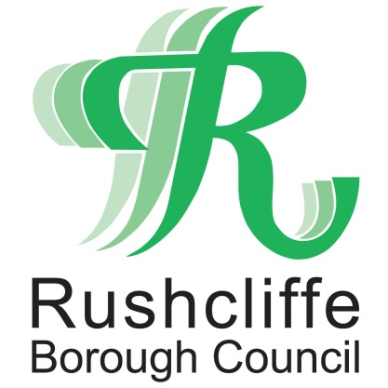 | Press Release

FOR IMMEDIATE RELEASE REF. REACH
18.09.20

Meet, Greet and Eat project given
funding by Reach Rushcliffe

A volunteer group that includes those with learning disabilities and additional needs is the latest group to receive funding from Reach Rushcliffe providing vital food packages for elderly residents and those at risk of social isolation and loneliness.

The Meet, Greet and Eat project is receiving funds as part of Rushcliffe Borough Council’s initiative which was launched in May aiming to tackle the issues and uses surplus food to create the food packages that are delivered weekly to those in need.

The project will use the funds to work with local young people’s centres to support more young people and adults with the additional needs join its team of coordinators.

It will also look to further their skills and understanding of the hospitality industry in a supportive community environment.

The project is one of a number of successful applications to the Reach Rushcliffe fund.

Deputy Leader of the Council Cllr Debbie Mason met with members and volunteers of the project at Wellbeck Hall in West Bridgford.

Cllr Mason said: “We are thrilled to provide funding to the Meet, Greet and Eat initiative, which will allow more young people to get involved in their kitchen giving them incredibly valuable skills that will no doubt help them in the future.

“Not only does the project provide this experience, but the packages are put together with food that would have otherwise been wasted and are delivered to elderly residents and families who may be at risk of social isolation in their areas.”

Project Coordinator Farah Jamil, who also acts as chef in the Meet, Greet and Eat said: “We’re are delighted to receive funding through Reach Rushcliffe which means we are able to help more young people join our team and also cover further material costs.

“The skills we can teach young people are so important for their future. Not just in the kitchen, but socially, these are skills that can be transferred to future job roles.

“A thank you to Wellbeck Hall who allow us to use their kitchen to safely prepare the food packages and ensure we can reach out to vulnerable residents with a friendly face from one of the team.”

- ENDS -

NOTE TO EDITORS
For information please contact the Rushcliffe press office on 0115 9148 555 or media@rushcliffe.gov.uk

For the latest news and events, follow @rushcliffe on Twitter or Rushcliffe on Facebook or go to the council's website.

