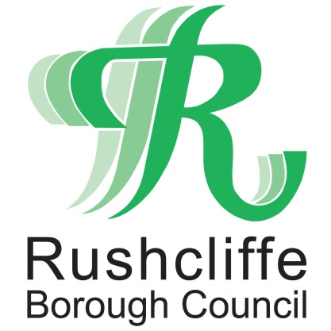 | Press Release

FOR IMMEDIATE RELEASE REF. TRACK
18.09.20

Always leave your contact details at pubs, restaurants, hairdressers and public premises to help combat coronavirus
Residents in Rushcliffe and wider Nottinghamshire are being reminded they must by law record their contact details when visiting pubs, restaurants, hairdressers, premises and venues from today (Friday) to help track and trace cases of coronavirus.
Businesses and other public settings where people meet socially including hospitality, close contact and leisure venues across the County are now obliged to collect the data to tackle the spread of the pandemic.
Details must be stored for 21 days and shared with NHS Test and Trace if requested. Businesses can now be fined if they fail to take specified steps to collect contact information or taking bookings for groups of more than six.
Businesses and organisations had been advised to collect and share data earlier this year, with many effectively doing so.
Following the recent move to ban social gatherings of more than six people, the data collection programme is now law whether through using a designated QR code available for all at https://covid19.nhs.uk/ through a smart phone or recorded in writing.
Nottinghamshire County Council and Rushcliffe Borough Council are asking residents to play their part by ensuring a member of staff at each premise always asks for details, or if they are not requested, to inform the authority by emailing envhealth@rushcliffe.gov.uk
The contact details being recorded at each site should include:
- name of each person in the party
- contact number
- date of visit
- arrival time
- departure time, if possible
Jonathan Gribbin, Director of Public Health for Nottinghamshire said: “When eating out at a café, pub or restaurant, or visiting another public venue, everyone should be providing full and accurate contact details of everyone in their group.

“This NHS Test and Trace Service is important for tracking and preventing the spread of COVID-19. Businesses have a clear duty to support this service.”
Venues must also keep a record of all staff working on the premises on a given day and their contact details.
All collected data must comply with GDPR and will not be kept for longer than necessary.
Data collection should be as straightforward as possible for organisations. Each has the freedom to collect the data in a way that best suits them, either using an existing system or finding a new solution.
Businesses should also continue to follow the government’s comprehensive workplace guidance with practical steps employers should take to make workplaces COVID-secure and ensure employees feel safe in their place of work.
Support for business owners in Rushcliffe is available by contacting the Borough Council via email at envhealth@rushcliffe.gov.uk or calling 0115 981 9911.

- ENDS -

NOTE TO EDITORS
For information please contact the Rushcliffe press office on 0115 9148 555 or media@rushcliffe.gov.uk

For the latest news and events, follow @rushcliffe on Twitter or Rushcliffe on Facebook or go to the council's website.

