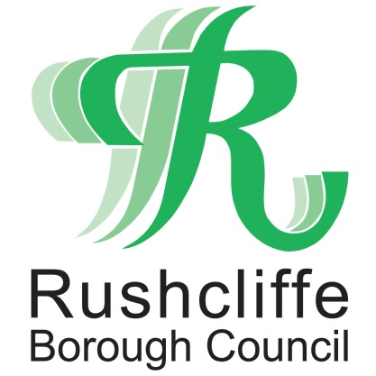 | Press Release

FOR IMMEDIATE RELEASE REF CREM
18.06.21

Work on new Rushcliffe Oaks crematorium
begins later this summer

Work is due to start on a new crematorium facility and community space in Rushcliffe later this summer known as Rushcliffe Oaks, reflecting the connection back to nature and wildlife and Rushcliffe Borough Council’s commitment to improving the biodiversity of the site.

The modern contemporary building will be located in Stragglethrope near Cotgrave and will provide an environmentally conscious building and memorial gardens that are sensitive to its surroundings with more information available at www.rushcliffeoaks.co.uk

The Council is still seeking to be carbon neutral in its operations by 2030 and this is reflected at the heart of its design and thought process for the new facility.

Through the use of innovative technologies and renewable energy sources, there are plans for a greener electric powered cremator rather than the more traditional use of gas, lowering CO2 emissions by around 90 per cent, making Rushcliffe Oaks one of the first in the country to invest in this new technology.

It is anticipated it could open in summer 2022 and will be operated and managed directly by the Council.

Final designs are set to go on display soon as part of ongoing engagement with residents and stakeholders, dates to be announced shortly.

Leader of the Council Cllr Simon Robinson said: “There will be public engagement sessions in July to keep everyone up to date with the latest news on the project.

“We look forward to sharing how our vision for a sensitive, green and forward-thinking facility is being realised.

“We want to show how it will be sensitively developed and how the grounds will still encourage local nature to thrive.

“We will listen and look to understand the views of local communities and families on how we can make such an important new facility work for their needs.

“It will be designed to provide the space and high level of service that the community expects and meet those green aspirations that are such an important part of this project.”

ENDS

NOTE TO EDITORS

For information please contact the Rushcliffe press office on 0115 9148 555 or media@rushcliffe.gov.uk

For the latest news and events, follow @rushcliffe on Twitter or Rushcliffe on Facebook or go to the council's website.

