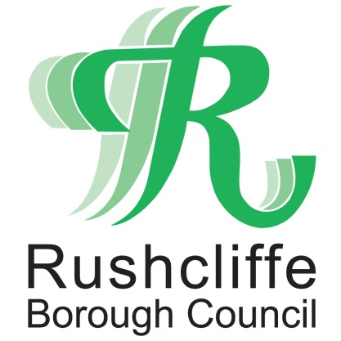 | Press Release

FOR IMMEDIATE RELEASE REF CUSTOMER
18.06.21
Rushcliffe Borough Council customer service centres to safely open from June 21
Rushcliffe Borough Council’s Customer Service centre and contact points at West Bridgford, Cotgrave, East Leake and Bingham will re-open and warmly and safely welcome back customers from next Monday June 21.
The centres will operate with COVID-19 measures in place, in line with the government’s extension of the step 3 roadmap as customers will be invited to continue to keep distance, use hand sanitiser on arrival and wear a facemask when visiting any site.
In West Bridgford, an appointment service will operate on Mondays, Thursdays and Fridays but it is anticipated many customers will be able to arrange an appointment at short notice on arrival at the centre.
Walk-in services for photocopying and self-scan station will be available without appointment.
In Cotgrave a walk-in service will operate before 1pm on contact point opening days and appointment service from 1pm-5pm.
Opening times will be:
- Rushcliffe Customer Service Centre, Fountain Court, Gordon Road, West Bridgford, NG2 5LN
Mondays and Thursdays 8.30am-5pm, Fridays 8.30am-4.30pm – appointment only
- Cotgrave Hub, Rivermead, Cotgrave, NG12 3UQ
Tuesdays 8.30am-1pm walk-in service, 1pm-5pm appointment only
- East Leake Library, Gotham Road, LE12 6JG.
Wednesdays 8.30am-5pm walk-in service
- Bingham Health Centre, Newgate Street, NG13 8FD
Thursdays 8.30am-5pm walk-in service
Rushcliffe Borough Council’s Cabinet Portfolio Holder for Finance and Customer Access Cllr Gordon Moore said: “We’re delighted we can safely re-open customer centres and contact points with measures in place to protect our customers and staff.
“We know many people still value face to face customer service and we can’t wait to welcome residents back to our sites where a friendly and safe visit awaits.
“We’ll monitor opening hours and continue to look at the ways residents most engage with us so we can deliver this service in line with demand. For any questions on visiting our sites or to make an appointment visit www.rushcliffe.gov.uk “
- ENDS -
NOTE TO EDITORS
For information please contact the Rushcliffe press office on 0115 9148 555 or media@rushcliffe.gov.uk
For the latest news and events, follow @rushcliffe on Twitter or Rushcliffe on Facebook or go to the council's website.

