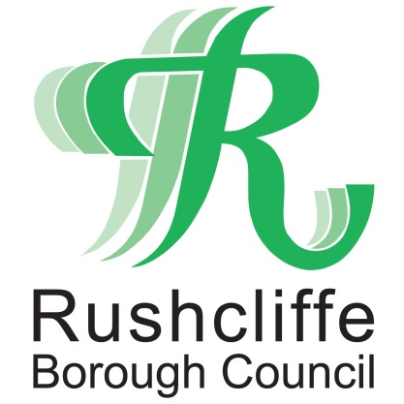 | Press Release

FOR IMMEDIATE RELEASE REF PROMS
18.06.21

Proms in the Park set for September slot

Following the government’s COVID-19 roadmap update on Monday (June 14), Rushcliffe Borough Council’s annual Proms in the Park event is now set to take place later this summer on Saturday September 18.

The Bridgford Park music event in West Bridgford will be rescheduled from its usual Armed Forces Day slot on the last Saturday of June.

It is hoped this will mean being able to accommodate a greater number of people and safely offer food and drink outlets and fringe stalls and attractions and welcome local Armed Forces representatives, not possible under the current COVID restrictions.

For event enquiries email communitydevelopment@rushcliffe.gov.uk or visit www.rushcliffe.gov.uk

ENDS

NOTE TO EDITORS

For information please contact the Rushcliffe press office on 0115 9148 555 or media@rushcliffe.gov.uk

For the latest news and events, follow @rushcliffe on Twitter or Rushcliffe on Facebook or go to the council's website.

