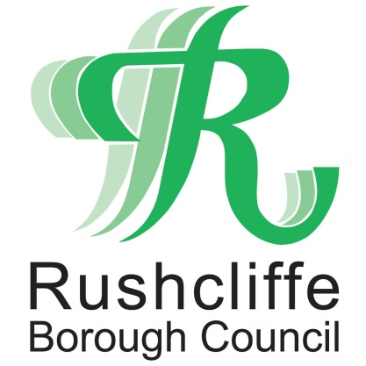 | Press Release

FOR IMMEDIATE RELEASE REF FIREWORK
18.03.21

Council to discontinue use of
loud fireworks at events

Rushcliffe Borough Council’s Cabinet has agreed a recommendation to discontinue the use of loud fireworks at its events.

It was decided at the authority’s Cabinet meeting on March 9 that all future events will look to replace the celebrations with quieter alternatives to protect pets and residents with disabilities from the potential noise pollution they can cause.

The Council is also set to encourage external event operators and households in the Borough to adopt a similar approach and is among the first local authorities to make such a decision.

Lower noise fireworks are an alternative for those looking to celebrate whilst also considering vulnerable members of their local community and are available from retailers.

Those affected by loud fireworks can include those with sensory processing disorders, hearing conditions, post-traumatic stress disorder and with respiratory conditions such as asthma, as well as pets, farm animals and wildlife.

The authority’s Cabinet Portfolio Holder for Community and the Environment Cllr Abby Brennan said: "Whilst fireworks can be a fun and enjoyable way of marking special occasions for some, we also understand louder fireworks can cause concerns for residents and their pets.

“By being one of the first Councils to make this decision across the UK, we hope that many other local authorities and organisations follow suit.

"We would also encourage event operators in Rushcliffe to also look at possible alternatives at their events.”

- ENDS -

NOTE TO EDITORS

For information please contact the Rushcliffe press office on 0115 9148 555 or media@rushcliffe.gov.uk

For the latest news and events, follow @rushcliffe on Twitter or Rushcliffe on Facebook or go to the council's website.

