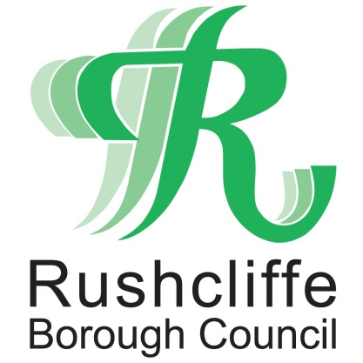 | Press Release

FOR IMMEDIATE RELEASE REF. TESTING
18.03.21

Rapid community testing site
to visit Cotgrave

A new rapid mobile community testing site is set to visit Cotgrave, providing local residents with regular access to asymptomatic testing.

Around one in three people infected with COVID-19 show no symptoms at all and could potentially spread the disease without knowing it.

The new site at Cotgrave Hub Car Park is located next to the police station and will launch on Saturday, March 20.

The unit will be open between 10am and 5:30pm every Wednesday and Saturday for local residents to get an asymptomatic COVID-19 test if they’re not displaying any symptoms.

The new testing facility has already started its journey around Nottinghamshire in Ollerton and will be moving on to Kimberley and then Cotgrave later in the week.

The new mobile sites give anyone the opportunity to get tested, including working aged residents, with no symptoms, who have to travel to work. No appointments are necessary at the testing site, visitors will simply be asked to register to get their results.

The test only takes a few seconds and results are delivered within 60 minutes directly to a smartphone. The test is designed to identify anyone who may have the virus and who may be, unwittingly, putting their colleagues, households or support bubbles at risk.

Rushcliffe Borough Council’s Leader Cllr Simon Robinson said: “This new asymptomatic testing site will provide yet another means for people to get tested and help us all in the fight against COVID-19.

“We know that as many as one in three individuals with the virus don’t display any symptoms, so sites such as this rapid centre in Cotgrave are crucial in helping us to ensure people are self-isolating when they need to.

“I encourage local residents who are not exhibiting symptoms to visit this new site, even if they’re feeling well.

“Regular asymptomatic testing will help protect their friends, family and our local communities in the weeks ahead and ensure this virus doesn’t spread further undetected.”

Jonathan Gribbin, Director of Public Health at Nottinghamshire County Council said: “Community testing is a useful tool in enabling us to identify people who have Covid-19, but who are without symptoms, so that information and support can be provided to help them isolate.

“These additional mobile testing units will make testing available to even more people. Regular testing will help to reduce the spread of infection.

“I am pleased with the numbers of people who do not have symptoms and are coming forward for testing. Many of them have said that they know it is the right thing to do for their community. I want to acknowledge that and thank them.

“We have eight testing sites across the county, and with these new mobile testing units, we will be able to offer this facility to even more people who have to leave home for work. These tests are quick, with results available in around 30 minutes.

“As we look towards the future with the easing of restrictions over the weeks and months ahead, it is important for people to develop the habit of getting a test regularly and making testing part of their weekly routine.

“It is still important to remember that people who test negative should continue to follow every aspect of the lockdown and Hands, Face, Space rules.”

The new mobile test centre in Rushcliffe opens on Saturday March 20 at Cotgrave Hub Car Park, beside the police station.

Opening hours are Wednesday and Saturday, from 10am to 5:30pm to anyone who has no symptoms of Covid-19 and who hasn’t had a positive test in the last 90 days. Under 16s can be tested but must be accompanied by an adult.

Find out more about the site by visiting www.rushcliffe.gov.uk/communitytesting

- ENDS -

NOTE TO EDITORS
For information please contact the Rushcliffe press office on 0115 9148 555 or media@rushcliffe.gov.uk

For the latest news and events, follow @rushcliffe on Twitter or Rushcliffe on Facebook or go to the council's website.

