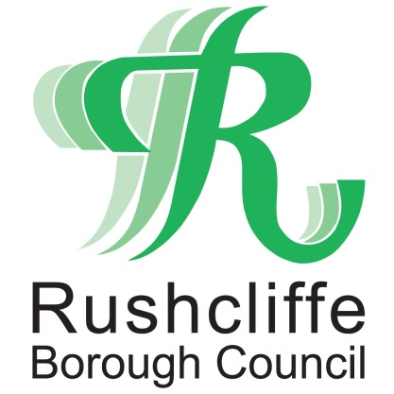 | Press Release

FOR IMMEDIATE RELEASE REF. CHECK
17.10.20

Pub, bar and restaurant COVID checks increased to support
businesses trading securely

COVID-19 compliance checks at pubs, bars, restaurants and food and drink outlets are increasing this weekend across Greater Nottingham to further support business owners trading securely.

Environmental Health Officers from Rushcliffe Borough Council, Gedling Borough Council and Broxtowe Borough Council are providing support to business owners to maintain their secure practices with over 110 extra visits to premises across the three areas, backed by Nottinghamshire Police.

The checks are building on the teams’ activity of recent weeks, helping owners and staff understand and apply the latest rule changes after Nottinghamshire’s move to being a ‘high’ risk area this week.

From socially distanced tables, table service and some outlets offering safe outdoor areas to accommodate rule of six, officers will offer advice and assistance to owners on how to maintain safe premises to maximise customer safety and encourage ‘Hands Face Space’ when not sat at a table.

Jonathan Gribbin, Director of Public Health at Nottinghamshire County Council, said:
“As we move into the first weekend of living at high alert level, it’s important that we all play our part to help stop the spread of infection.

“If you are planning on going out, please remember that you cannot mix indoors with another household unless it’s your support bubble and the rule of six applies outside.

“The majority of businesses are going to great lengths to help keep their customers, staff and visitors safe from COVID-19 and I’d like to thank them for their diligence. Their actions are supporting the work to safeguard local jobs, local people and protect the NHS and health services.”

Rushcliffe Borough Council’s Cabinet Portfolio Holder for Neighbourhoods Cllr Rob Inglis said: “We’re here to help hospitality businesses operate securely and the teams are committed to ensuring the business owners have all the latest advice available to implement the measures on their premises and communicate them effectively to staff.

“The vast majority of businesses are doing an incredible job in the circumstances and we thank them for their ongoing dedication to operate securely.

“We have taken action where we have needed to with some outlets but this has been required on a very few select occasions so you can be assured outlets have your safety in mind when you book a meal or pop in for your favourite drink.”

Leader of Gedling Borough Council, Councillor John Clarke said: “This weekend of action will help the ongoing work we are doing to support our local businesses during the pandemic. We have already visited over 130 businesses across the borough in the last few weeks and the vast majority are doing everything they can to make sure their premises are safe for customers.

“This joint operation with our colleagues at Broxtowe and Rushcliffe is being done to reinforce the importance of doing everything we can to try and get the number of cases down in our boroughs while keeping our businesses open. It is a real challenge for everyone but we are here to help our businesses and reassure our residents.”

Leader of Broxtowe Borough Council, Councillor Milan Radulovic MBE said: “With a dedicated team of COVID Information Officers and a new Markets Officer, we have been working with businesses in Broxtowe every step of the way, offering support and advice and helping them continue to implement changes needed to keep people safe.

“We need to do our bit to help local businesses continue but also keep their teams and our residents protected as much as possible from COVID-19.”

Nottinghamshire Police will also have a presence in town and village centres to provide further reassurance to business owners and offer any advice around customers leaving premises safely at 10pm closing times.

Neighbourhood Inspector Craig Berry said: “We are fully behind the councils as they endeavour to carry out these spot checks on businesses and as police we will support them in this approach.

“We are very grateful to all those people and businesses who are complying with the rules, and I am very pleased to say the vast majority are. Where there are issues of the rules not being followed we will look to encourage compliance and only where this is not possible will we enforce.”

All the latest COVID-19 advice for residents and businesses is available at www.rushcliffe.gov.uk www.gedling.gov.uk and www.broxtowe.gov.uk

- ENDS -

NOTE TO EDITORS
For information please contact the Rushcliffe press office on 0115 9148 555 or media@rushcliffe.gov.uk

For the latest news and events, follow @rushcliffe on Twitter or Rushcliffe on Facebook or go to the council's website.

