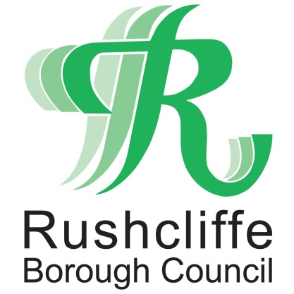 | Press Release

FOR IMMEDIATE RELEASE REF. SAFE
17.10.20

Continue to Shop Local Shop Safe and support your favourite pubs,
restaurants, shops and outlets

Continue to Shop Local and Shop Safe and support local pubs, restaurants, shops and outlets with their COVID-19 secure practices.

That’s the message from the Deputy Leader of Rushcliffe Borough Council Cllr Andy Edyvean who is asking residents to visit hospitality and retail outlets who are still trading safely in line with the latest COVID-19 ‘high’ tier 2 restrictions.

This means customers can continue to enjoy a bite to eat or drink at their favourite outlet in the Borough, with the Council’s Environmental Health team continuing to provide round the clock support and checks to business owners to adapt to secure COVID-19 practices.

From socially distanced tables, table service and some outlets offering safe outdoor areas to accommodate rule of six, there is still every opportunity to support your pub, bar, restaurant, tea and coffee shop or outlet.

Cllr Edyvean said: “The new restrictions should not stop us supporting our local economies and high streets and therefore please continue to Shop Local Shop Safe.

“Businesses are in the vast majority of cases doing a wonderful job adapting to the measures and we want everyone to feel they can still visit their favourite outlet with confidence.

“We have taken action where we have needed to ensure customers’ safety but so many businesses are rising to the challenge of the new rules brilliantly.

“As a Council we are here to support them in line with additional visits from our Environmental Health teams this weekend.

“You can be assured outlets have your safety in mind when you book a meal or pop in for your favourite drink.

“Don’t Forget Hands Face Space and ensure you stick to the rule of 6 outdoors.”

All the latest advice to residents and businesses is available at www.rushcliffe.gov.uk

- ENDS -

NOTE TO EDITORS
For information please contact the Rushcliffe press office on 0115 9148 555 or media@rushcliffe.gov.uk

For the latest news and events, follow @rushcliffe on Twitter or Rushcliffe on Facebook or go to the council's website.

