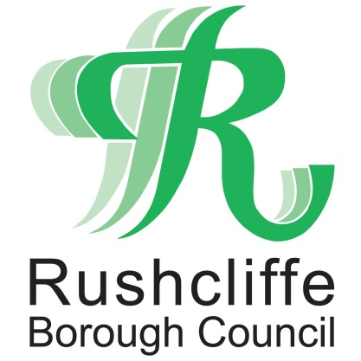 | Press Release

FOR IMMEDIATE RELEASE REF FLY-TIP
17.06.21
Over 70 fly-tipping fines issued in Rushcliffe in just six months

Action on rogue fly-tippers has increased hugely in Rushcliffe since the beginning of 2021 with over 70 fixed penalty notices given to those found blighting local spots with domestic or commercial waste.
It follows on from Rushcliffe Borough Council’s partnership with Waste Investigations Support & Enforcement (WISE) that sought to build on its existing tools to find and fine or prosecute those who flout the rules as part of even more focus on tackling the nuisance issue.
Since January their environmental enforcement service now operates across the Borough seven days a week, investigating where the waste has come with the marked increase on fines down to thorough searches on items linked to properties and individuals.
It compares with five fines administered in the previous six months before the partnership.
New bins and signage from the Council also now instruct motorists to ‘bin it, don’t dump it’ at lay-bys in the area, backing up continued surveillance on trade waste and household items being dumped on roads and verges and monitoring sites to catch those in the act.

Residents and businesses are reminded to check that any company or individual they employ to dispose of their waste holds the relevant Trade Waste Carriers’ licence to avoid their unwanted goods contributing to fly-tips.

This can be completed by them showing the relevant licence in person and checking it with the Environment Agency’s listings of registered businesses here: https://bit.ly/1UFAWfn

The Council’s Cabinet Portfolio Holder for Environment and Safety Cllr Rob Inglis said: “The message is clear, we will not tolerate fly-tipping anywhere in Rushcliffe and we will continue to take action against persons who do not dispose of their waste responsibly.

“Fly-tippers are warned that we are taking this very seriously and by our various monitoring means we will take more positive action and prosecute from any evidence gathered and that includes seizing the vehicles involved.

“Residents have a huge part to play too by always checking that anyone they pay to take items away from their home is a registered waste carrier by requesting to view the appropriate Environment Agency licence.
“Please be our extra eyes and ears and report any suspicious activity at www.rushcliffe.gov.uk.”

- ENDS -
NOTE TO EDITORS

For information please contact the Rushcliffe press office on 0115 9148 555 or media@rushcliffe.gov.uk

For the latest news and events, follow @rushcliffe on Twitter or Rushcliffe on Facebook or go to the council's website.

