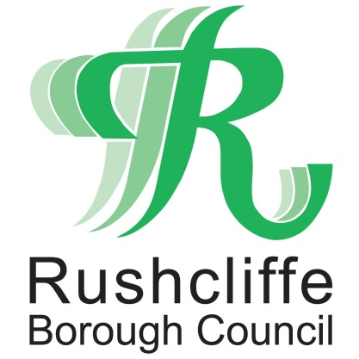 | Press Release

FOR IMMEDIATE RELEASE REF CAR PARK
17.06.20
Rushcliffe car park charges and restrictions to resume from June 29

Car parks across Rushcliffe are resuming all regular charges and restrictions from June 29 to help balance the needs of businesses, shoppers and visitors to town centres, villages and parks.

Structured daytime parking rules at Bridgford Road, Gordon Road and Nursery Road car parks in West Bridgford, Bunny Lane in Keyworth, Needham Street in Bingham and Rushcliffe Country Park will return, once again ensuring a healthy turn over of spaces to help support local economies in these locations.

All motorists are advised to follow social distancing measures in line with central government guidance when using car parks across the Borough.
Rushcliffe Borough Council’s Executive Manager for Neighbourhoods Dave Banks said: “We are pleased that our car parks can now resume their normal operations and enable the increasing numbers of visitors, shoppers and businesses to our towns and villages to find a space easily.
“There has been a significant increase in the usage of our car parks this week, as many retailers welcomed back customers to their premises, so now is the right time to help support those business owners and consumers with the return of regular parking regulations and charges.
“Resuming normal parking charges in some locations will continue to help local businesses as it did before the pandemic began, ensuring shoppers and visitors can find a space to park whilst crucially ensuring businesses benefit.
“Charges are re-invested back into car parks that are safe and attractive and for maintenance on lighting, resurfacing, ticket machines and improvements such as the highly popular RingGo service.”
The Council launched its Off Street Car Parking Strategy in 2018 with a focus on supporting the right balance of duration, charging and other factors in each location to support local economic prosperity and has assessed its resumption will assist businesses recovering from COVID-19 changes.
Contactless payment for parking can be made quickly and easily using the
RingGo app, by call, text or online at www.myringgo.co.uk across the authority’s five Pay and Display car parks.

- ENDS -

NOTE TO EDITORS

For information please contact the Rushcliffe press office on 0115 9148 555 or media@rushcliffe.gov.uk

For the latest news and events, follow @rushcliffe on Twitter or Rushcliffe on Facebook or go to the council's website.

