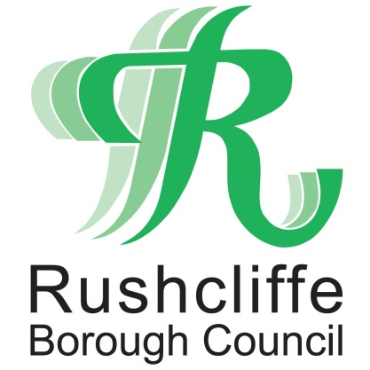 | Press Release

FOR IMMEDIATE RELEASE REF. TAKEAWAY
17.06.20

Pubs and restaurants reminded how to operate safely as takeaway fined for breach of Coronavirus regulations
Rushcliffe Borough Council is reminding food and drink business owners how to operate as safely as possible during COVID-19 after issuing a fixed penalty notice to a takeaway in breach of the current Coronavirus regulations.
On June 12 the authority’s officers fined Trent Bridge Spice in West Bridgford for allowing tables and chairs to be placed inside their premises on Radcliffe Road that were subsequently used by customers against current restrictions due to Coronavirus.
In March, planning rules were changed by central government to allow restaurants, cafes and pubs to apply to run as takeaways for up to 12 months and the authority wishes to support businesses wherever possible.
Once a licence has been secured, owners then need to work with the Council’s Environmental Health team to trade as safely as possible.
This includes ensuring outdoor seating areas are not available until further notice and safe social distancing and queuing measures inside and outside the premises are in place.
All food and drink must then be taken away from the premises and customers advised to not congregate outside the business within guidelines outlined by government here https://bit.ly/2BeyN8Y.

Rushcliffe Borough Council’s Cabinet Portfolio Holder for Environment and Safety Cllr Rob Inglis said: “Our teams have been visiting businesses to ensure they are able serve customers securely and to give advice on any adaptations required. Any breach will be taken very seriously and a blatant disregard for the rules will not be tolerated.

“We understand the current financial climate for businesses and have advised the owners in this case to draw up steps they can take to trade more safely in future.”
Further information is available on the government website at https://bit.ly/2zAFbXM.
- ENDS -

NOTE TO EDITORS
For information please contact the Rushcliffe press office on 0115 9148 555 or media@rushcliffe.gov.uk

For the latest news and events, follow @rushcliffe on Twitter or Rushcliffe on Facebook or go to the council's website.

