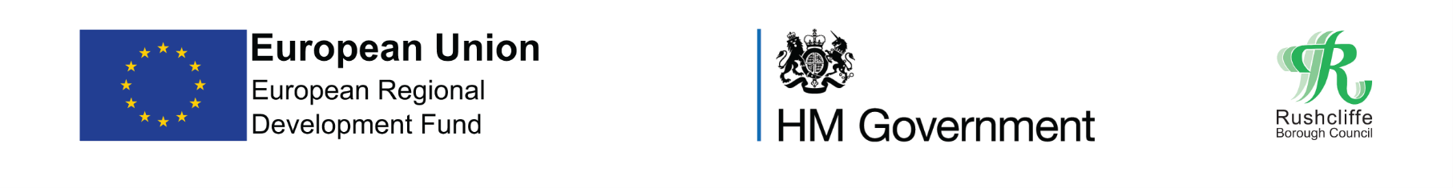
Press release

FOR IMMEDIATE RELEASE REF. AMBASS
16.10.20

High Street Ambassadors provide assurance and advice in Rushcliffe town and village centres

Rushcliffe Borough Council has appointed a team of High Street Ambassadors to the Borough’s town centres to provide assurance and advice to residents and visitors in line with current COVID-19 restrictions, with funding provided by the European Regional Development Fund.

From this weekend the friendly faces will be on hand to answer questions and provide useful advice and reminders to customers about staying safe whether out shopping, heading for a drink or bite to eat or enjoying a stroll in parks and open spaces.

Teams will be in Bingham, Radcliffe, Ruddington, Keyworth, East Leake, Cotgrave and West Bridgford in the coming days and weeks to provide the advice and support for local high streets reopening safely.
They will outline how retail, hospitality and venues with COVID-secure guidance are still safe to visit as everyone is encouraged to continue to Shop Local Shop Safe and support local economies.
Rushcliffe Borough Council’s Deputy Leader Cllr Andy Edyvean said: “As we continue with these new restrictions across the Borough and Nottinghamshire, it is important that our residents feel safe in their local town and village centres and that they understand how to visit safely within the new regulations.

“The High Street Ambassadors are a face you can trust to point you in the right direction for advice if you have any questions.

“They are not in place to enforce the restrictions but reassure residents help is available.

“Should you need to know for example where and when to wear a facemask, how outlets are accommodating rule of six in outdoor seating and social distancing and the other measures our great local businesses have in place, they are there to help.”

For all the latest advice on following COVID-19 rules in Rushcliffe visit www.rushcliffe.gov.uk

- ENDS -

NOTE TO EDITORS
For information please contact the Rushcliffe press office on 0115 9148 555 or media@rushcliffe.gov.uk

For the latest news and events, follow @rushcliffe on Twitter or Rushcliffe on Facebook or go to the council's website.

European Regional Development Fund

The project is receiving funding from the England European Regional Development Fund as part of the European Structural and Investment Funds Growth Programme 2014-2020. The Ministry of Housing, Communities and Local Government (and in London the intermediate body Greater London Authority) is the Managing Authority for European Regional Development Fund. Established by the European Union, the European Regional Development Fund helps support innovation, businesses, create jobs and local community regenerations.

For more information visit https://www.gov.uk/european-growth-funding

