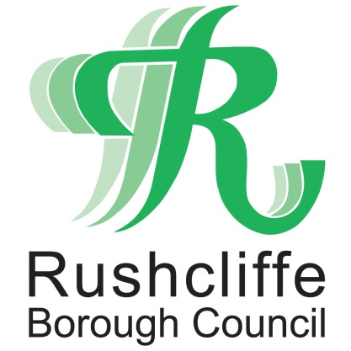 | Press Release

FOR IMMEDIATE RELEASE REF. REACH
16.09.20

Community garden receives vital funds to further combat social isolation

A community project has received vital funding from Reach Rushcliffe to help develop a community garden to provide residents with access to green space, help them grow fruit and vegetables and learn more about horticulture.

Cotgrave community garden is now cultivating the land adjacent to their Cotgrave Welfare Club site thanks to funds from Rushcliffe Borough Council’s initiative. The project aims to encourage individuals to attend green fingered get togethers of six or less and help further tackle social isolation and loneliness.

The group will use the funds to employ a project worker who will help further promote the initiative to reach those at risk of social isolation in the community and to recruit volunteers.

The garden will also provide food to the Super Kitchen who are currently providing a meal delivery and collection service where residents pay a suggested donation of £1.

The project is one of a number of successful applications to the Reach Rushcliffe fund.

Deputy Leader of the Council Cllr Debbie Mason met members and volunteers of the Super Kitchen and community garden at their base at the Cotgrave Welfare Club.

Cllr Mason said: “It is great to award funding to the Super Kitchen as their work with local groups and vulnerable residents is so important.

“This community garden will help those at risk of social isolation meet new people and stay active through gardening.

“We know that healthy food and exercise is incredibly important and both these aspects can be witnessed when group members meet safely and in a socially distanced manner to grow the fruit and vegetables.

“It’s also been inspiring to see this community group turn an otherwise unused land and transform it into a site that so many people will benefit from and enjoy for years to come.”

Jill Mathers, Project Worker at Cotgrave Super Kitchen said: “Our aim is to create a sustainable, volunteer led green space accessible to all, providing residents with an opportunity to learn more about the importance of growing and eating healthy foods and this funding will help us achieve this.”

“It is brilliant to receive funding through Reach Rushcliffe and the Borough Council as we now hope to extend our group to reach more residents.”

- ENDS -

NOTE TO EDITORS
For information please contact the Rushcliffe press office on 0115 9148 555 or media@rushcliffe.gov.uk

For the latest news and events, follow @rushcliffe on Twitter or Rushcliffe on Facebook or go to the council's website.

