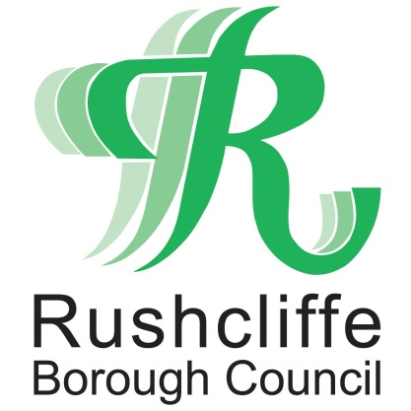 | Press Release

FOR IMMEDIATE RELEASE REF. CARBON
16.07.20

Environment role created to further Rushcliffe Borough Council's goal to be carbon neutral

Rushcliffe Borough Council is taking further steps towards its goal for its operations to be carbon neutral by 2030 with the creation of a Team Manager for Environment in its Community Development team.

Despite the pressures of COVID-19 on the authority, it is continuing with its green priorities to recruit to the role and demonstrate its commitment towards recovering from the pandemic in line with its further investment in its Climate Change Action Reserve.

The authority is seeking an ambitious, forward thinking individual to lead a team in delivering the Council’s commitments to achieving carbon neutral status including in its Carbon Management Action Plan that is tackling Property Assets, Fleet, Policy and Regulation in the organisation to reduce emissions over the next decade.

The position will also play a key role in influencing the Borough’s communities, internal stakeholders, groups and businesses to take similar steps towards reducing their emissions.

In March the Council’s Cabinet approved plans to become ‘Carbon Clever’ and reach the 2030 deadline with an added £1m towards the reserve in conjunction with an innovations from an internal working group that is now implementing changes.

Future Carbon Clever activities could include developing a tree planting plan for Council land, enforcing minimum energy standards in the private rented sector and the promotion of carbon reduction policies to developers working in Rushcliffe.

The authority’s Green House Gas Report 2018-19 was also released earlier this year that announced that the organisation had cut emissions by 40% since 2008/9, exceeding its previous target for 2020 by 10%.

Rushcliffe Borough Council’s Deputy Leader Cllr Debbie Mason said: “The work already completed by our internal working group is very exciting and sets us challenging but achievable targets for the future and we wish to recruit an individual to drive this project further.

“We are looking for someone who can demonstrate a real passion for the environment, show experience of working in partnership with partners and stakeholders to achieve real results and in line with governmental regulations and environmental sustainability best practices.

“As the recent Green House Gas Report demonstrates, we have a clear commitment to the environment and we will continue to support other organisations in making positive changes to become Carbon Clever themselves.”

The Carbon Management Action Plan is set to evolve in line with technological innovations and has been developed to integrate with the overarching D2N2 Energy Strategy in the region.

Interested applicants can apply at https://www.rushcliffe.gov.uk/jobs/jobtitle,53706,en.php or contact the Council’s Community Development Manager Derek Hayden on 0115 9148270 for an informal discussion on the role.

The closing date for applications is Sunday August 9.

- ENDS -

NOTE TO EDITORS
For information please contact the Rushcliffe press office on 0115 9148 555 or media@rushcliffe.gov.uk

For the latest news and events, follow @rushcliffe on Twitter or Rushcliffe on Facebook or go to the council's website.

