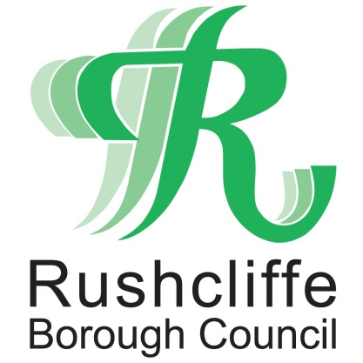 | Press Release

FOR IMMEDIATE RELEASE REF FLY-TIP
16.02.21
Appeal following three tonne fly-tip at rural walking spot

Rushcliffe Borough Council is appealing for information from members of the public after fly-tipping was found blighting a rural walking spot.

Three tonnes of bricks, rubble and other waste was found by the authority on February 14 at a car park adjacent to the Grantham Canal near Cropwell Butler at a location popular for walkers.

The news follows the Council partnering with Waste Investigations Support and Enforcement (WISE) earlier this year that has seen a significant rise in the number of fines issued for those fly-tipping, dog fouling and littering across the Borough.

Incidents have been investigated, leading to over 300 fines being issued.

However, the authority is still keen to receive information on anyone who witnessed the fly-tip or saw vehicles in the area on February 13 or 14 and would encourage reporting of any other fly-tipping in the Borough at https://bit.ly/3rUE4rt.

The webpage includes a facility to pinpoint the location of the fly-tip on a map which can help the Council locate items and aid their swift removal.
The Council’s Cabinet Portfolio Holder for Neighbourhoods Cllr Rob Inglis said: "Incidents like this generate much anger in our Community. I find it utterly deplorable that a small minority of people consider it is acceptable to dump rubbish and waste in our wonderful countryside.
“Offenders show a total disregard to our environment, our residents and to those having to clear it up, especially not knowing what hazards may lie within.
“It either falls upon us all, or just an innocent landowner to foot the bill for each occurrence.
“I appeal for anyone who recognises the source of the waste in this incident to please let us know by calling 0115 981 9911 or via our website www.rushcliffe.gov.uk.
“Rushcliffe's partnership with WISE highlights the increased commitment to tackle this anti-social crime. Investigations have already and will continue to identify the culprits.”

WISE’s environmental enforcement service operates across the Borough clamping down on dumped domestic and commercial waste seven days a week.

They target those who don’t dispose of their waste in a responsible way, or hand it over to non-registered waste carriers or create eyesores through dropping litter or failing to pick up after their dog’s waste.

Anyone caught fly-tipping can be issued with a £400 Fixed Penalty Notice or if they are observed littering or failing to pick up after their dog’s waste, will be issued with an on the spot £100 fine.

Failure to pay a Fixed Penalty Notice may result in prosecution being brought and a much higher fine being imposed by the Court as well as a potential criminal record.

- ENDS -

NOTE TO EDITORS

For information please contact the Rushcliffe press office on 0115 9148 555 or media@rushcliffe.gov.uk

For the latest news and events, follow @rushcliffe on Twitter or Rushcliffe on Facebook or go to the council's website.

