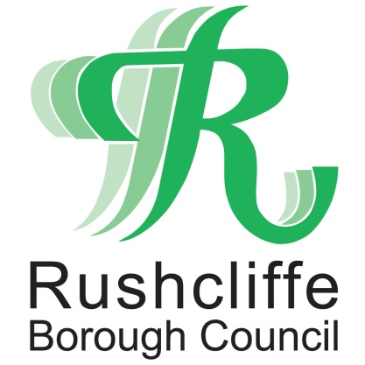 | Press Release

FOR IMMEDIATE RELEASE REF GRANTS
15.07.20

Second phase of discretionary COVID-19 grants now available for eligible business owners

Rushcliffe Borough Council is now inviting applications from eligible business owners on a second phase of COVID-19 Discretionary Business Grants Scheme designed for those yet to receive central government financial support.

This grant is aimed at small businesses who were not eligible for the Small Business Grant Fund or the Retail, Leisure and Hospitality Fund payments in April and who may have been unsuccessful with applications to the first phase of discretionary support outlined in June.

This central government support has now been reviewed with newly revised terms and previous applicants do not need to reapply with the Council will contacting them should they now be eligible for the funding.

Otherwise, new applications for eligible business owners can be completed until July 31 at www.rushcliffe.gov.uk/businesscoronavirus

The new terms include small and micro business owners who have ongoing property related costs of more than 5% of overheads, compared with 15% previously and those in the with a rateable value of less than £100,000 in the retail, hospitality and leisure sectors.

The eligible fall in income threshold has also been lowered to 60%, compared with 80% in the first phase.

This will be assessed when compared to April and May last year and businesses must still not be eligible for other business rates based grants.

Businesses also need to have been trading on March 11 this year and will have to provide supporting information and documents to complete the process.
Rushcliffe Borough Council’s Cabinet Portfolio Holder for Business and Transformation Cllr Andy Edyvean said: “This second phase of funding will give even more business owners support at this very challenging time and to more yet to receive government support.
“We are committed to ensuring these further eligible business owners receive this discretionary grant but urge them to contact us as soon as possible ahead of the July 31 deadline and complete the online form.
“Successful applications are on a first come first served basis until the Government funding is exhausted and previous applicants will be contacted if they are now eligible under the new guidelines.”

ENDS

NOTE TO EDITORS

For information please contact the Rushcliffe press office on 0115 9148 555 or media@rushcliffe.gov.uk

For the latest news and events, follow @rushcliffe on Twitter or Rushcliffe on Facebook or go to the council's website.

