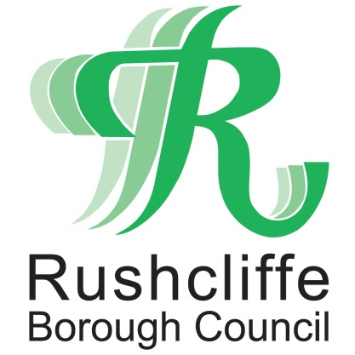 | Press Release

FOR IMMEDIATE RELEASE REF REACH
15.06.21

Reach Rushcliffe fund
further expanded to tackle
loneliness and isolation

Rushcliffe Borough Council has further extended its Reach Rushcliffe fund, dedicated to supporting projects across the Borough that tackle loneliness and isolation.

Being connected with other people matters for everyone’s health and COVID-19 has further highlighted how social isolation can be bad for our mental and physical health.

It’s fast becoming one of the greatest social challenges nationally and whilst often associated with older people who live on their own, it can affect anyone of any age and linked to issues such as obesity, smoking and can increase risk of dementia.

In line with Loneliness Awareness Week this week, town and parish councils, local groups and organisations can access funding from the scheme to apply for proposals to create, sustain or expand projects that could help reach out with a friendly face to those in need.

Applications typically range between £250 to £2,000 but larger applications will be considered.

Projects should aim to take steps to make contact and engage individuals or groups in Rushcliffe communities who may have little or no social contact.

This could be initiatives based around a structured befriending initiative to check on individuals, lunch clubs, or safe regular social meet up events in line with government advice or other projects.

Initiatives that have benefitted over the last 12 months include:

- Rushcliffe Community and Voluntary Service – operation of South Notts Befriending Service supporting 130 people with regular social calls. Volunteer management, support and training
- Rushcliffe School’s daily motivational hub – reaching out to up to 20 children a day and learning more about the importance of mental health
- Musicworks’ music café interactive wellbeing sessions – engaging hundreds of local people in sing a long and social sessions
- Ellerslie Cricket Club’s development of their walking cricket activity for residents in the over 50 age group.

Rushcliffe Borough Council’s Cabinet Portfolio Holder for Communities and Climate Change Cllr Abby Brennan said: “This fund aims to directly improve the quantity and quality of connections residents have with each other and local groups and we’ve been delighted to have supported over a dozen worthwhile groups in the last 12 months.

“We’ll be assessing funding applications to help with initiatives for those who may need our support, it’s so key we reach out to people suffering loneliness or isolation.

“We’re keen to hear from a wide range of groups and recognise that some small groups may need additional support to plan, deliver or evaluate their project so please get in touch.

“We want to hear from you too about what may help us reach out to more people across our communities who may benefit from Rushcliffe Reach. Email lparker@rushcliffe.gov.uk for more information.”

Proposals must demonstrate how they will tackle loneliness and make a difference to the health and wellbeing of participants, be community-led and sustainable with more information available at https://www.rushcliffe.gov.uk/health/reachrushcliffe/

Applications can be made by completing an application form at https://bit.ly/3fmhJ0q and initiatives could also work in conjunction with Rushcliffe’s GP practices and the established Rushcliffe Community Voluntary Service.

It is not anticipated the fund would extend to the running costs of an existing organisation but start-up costs for a new initiative may be considered.

ENDS

NOTE TO EDITORS

For information please contact the Rushcliffe press office on 0115 9148 555 or media@rushcliffe.gov.uk

For the latest news and events, follow @rushcliffe on Twitter or Rushcliffe on Facebook or go to the council's website.

