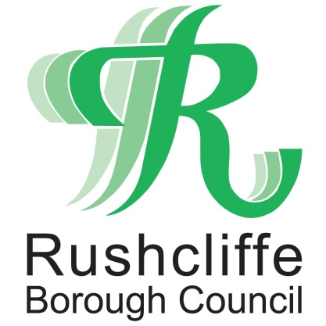 | Press Release

FOR IMMEDIATE RELEASE REF RESILIENCE
15.02.21
Join Rushcliffe 100 to hear expert advice on how to build your business resilience

Rushcliffe business owners are invited to an online event that will bring together over 100 businesses to help learn more about personal and business resilience.

The virtual gathering will include a chance for businesses to learn more about how they can manage their budget in 2021, an open discussion on the future of high streets and an overview of the business support available from the D2N2 Growth Hub.

Keynote speaker John Dabrowski will also be sharing his new online masterclass, specifically designed to help people deal with stress induced by COVID-19 and demonstrating how to change the way they process negative situations.

John is an international speaker, author and expert on mental resilience, overcoming adversity and succeeding in his early years to become a basketball international player.

The virtual event takes place on Friday March 5 from 10am to 12.30pm and business owners can book a place by visiting https://bit.ly/3a9ZOtu for a fee of £10, proceeds from the tickets sales donated to local charities.

They include Meet, Greet and Eat, Bingham Helping Hands and the Keyworth Community Project who have all been working hard to support their communities during the pandemic.

Rushcliffe Borough Council’s Deputy Leader and Portfolio Holder for Business and Economic Growth Cllr Andy Edyvean said: “This year has been incredibly challenging for many businesses and at the Council we continue to do everything we can to provide support.

“This event will provide an opportunity for businesses to connect with each other and to learn more about the support that is available. We have been so impressed with the resilience shown by many as we continue to face uncertainty but as ever, new ideas and discussion we find really assists local business owners.

“We are also very pleased that a large portion of the proceeds from this event will provide much needed support for three brilliant local charities who have done so much to support our local communities throughout the pandemic.”

John Collins, Chair of the Rushcliffe Business Partnership’s Steering Group said: “This year’s Rushcliffe 100 event will be very different as we are not able to get together as we usually would in person.

“However, it will still be a fantastic morning for Rushcliffe businesses to hear how they can make both their operations and their personal life more resilient.

“Personal mental resilience is something which is crucial due to the impact of the lockdown and we hope this event will help our business community deal with the challenges they are likely to face in 2021.”

- ENDS -

NOTE TO EDITORS

For information please contact the Rushcliffe press office on 0115 9148 555 or media@rushcliffe.gov.uk

For the latest news and events, follow @rushcliffe on Twitter or Rushcliffe on Facebook or go to the council's website.

