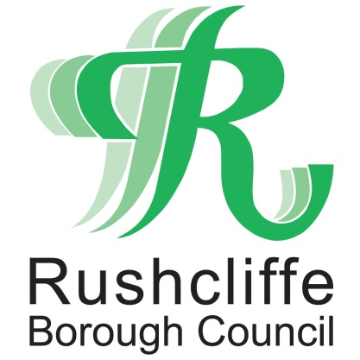 | Press Release

FOR IMMEDIATE RELEASE REF.GRANT
15.01.21

Vital national lockdown grants announced for eligible Rushcliffe businesses

Rushcliffe Borough Council has now outlined its plans to ensure vital central government grants reach businesses affected by the current national lockdown restrictions.

Eligible businesses can now apply for the funding at
www.rushcliffe.gov.uk/businesscoronavirus that is over and above any previous grant support.

To qualify for a grant, businesses must occupy a property listed as liable for national non-domestic rates and have been instructed to close in line with the current restrictions in the Borough from January 4, even if able to open for delivery or takeaway services.

Further discretionary support is set to be outlined as soon as possible.

Those who previously applied for a grant in previous tier or lockdown restrictions will be contacted with details of how to reapply.

All grants will be processed as quickly as possible with owners asked to ensure all supporting documents are included with any application.

The news builds on the authority having distributed nearly £34m of previous central government grants since last March to over 1,500 eligible businesses.

Rushcliffe Borough Council’s Deputy Leader Cllr Andy Edyvean said: “This is very welcome news following the Chancellor’s announcement earlier this month, further grants are available and we will quickly distribute them.

“We’re very aware of our businesses’ outlook as this awful pandemic continues and this offers many in the hospitality sector and other industries vital support.

“We’ll continue to assist central government in managing the impacts of COVID-19 wherever we can.

“For all other business support for business owners please contact our Economic Growth team by emailing econdev@rushcliffe.gov.uk “

- ENDS -

NOTE TO EDITORS

For information please contact the Rushcliffe press office on 0115 9148 555 or media@rushcliffe.gov.uk

For the latest news and events, follow @rushcliffe on Twitter or Rushcliffe on Facebook or go to the council's website.

