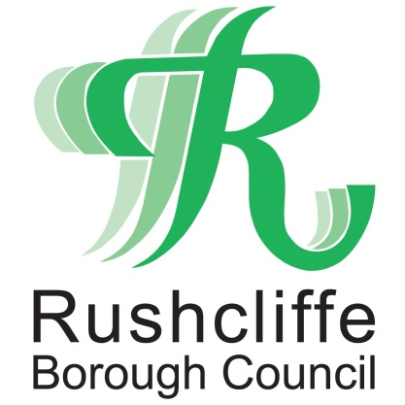 | Press Release

FOR IMMEDIATE RELEASE REF.PUB
15.01.21

Nottinghamshire pub owners, staff and customers fined after flouting COVID rules

A Nottinghamshire pub has been closed and its owners, staff and four customers fined after it was found to be serving alcohol inside the premises in breach of current national lockdown laws.

On the basis of information received, Nottinghamshire Police officers visited The Plough Inn in Cropwell Butler on January 13 to find four individuals sat around a table drinking and watching television with a member of staff.

Environmental Health and Licensing Officers from Rushcliffe Borough Council have now served its owners a fixed penalty notice of £1,000 in line with central government rules and Police have issued £200 fines to all customers and the three owners and staff present at the time of the breach.

The business has also received a prohibition notice ensuring it cannot allow individuals to enter the premises to consume food or drink.
Rushcliffe Borough Council’s Cabinet Portfolio Holder for Neighbourhoods, Cllr Rob Inglis said: “This is an exceptionally disheartening breach of the current lockdown restrictions when so many people are following the rules to protect lives and each other at the height of the pandemic to date.
“It is mindless, selfish and utterly irresponsible by all involved. We know businesses are facing an unprecedented trading situation but so many here in Rushcliffe have adapted brilliantly to offer takeaway and delivery safely instead of having to resort to flouting the rules.
"We always look to advise and educate business owners as to their responsibilities and we thank Rushcliffe business owners for their high compliance to date and for playing their part in keeping customers and staff safe.
“COVID restrictions are in place to protect everyone and we say to all business owners please do not place yourself in a position like this which is putting lives at risk. Contact us if you need support to trade.”
Rushcliffe Inspector Craig Berry said: "Officers from the local council and Nottinghamshire Police visited a pub in Cropwell Butler on Thursday following a routine check in.
"Through joint enforcement work from the police and the local council we attended yesterday (14 January 2021) and worked in a partnership approach to prevent further breaches of the legislation.
"The bar was issued with a prohibition notice and a fixed penalty notice by environmental health and licensing officers.
"We are pleased with the partnership approach and will not tolerate flouting the Covid-19 legislation and we will take positive action.
“We will investigate any reports of licensed premises and pubs that are reported of being open and in breach of the Governments Covid 19 regulations.
"Appropriate actions will be taken, this being a good example of partnership work with the local authority."

- ENDS -

NOTE TO EDITORS

For information please contact the Rushcliffe press office on 0115 9148 555 or media@rushcliffe.gov.uk

For the latest news and events, follow @rushcliffe on Twitter or Rushcliffe on Facebook or go to the council's website.

