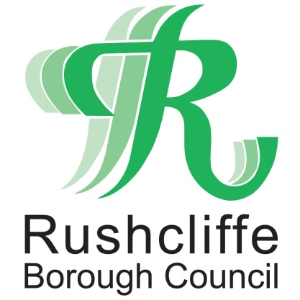 | Press Release

FOR IMMEDIATE RELEASE REF ANNIVERSARY
14.08.20
Rushcliffe joins commemorations for the
75th anniversary of VJ Day

Rushcliffe Borough Council is joining commemorations for the 75th anniversary of VJ Day and the end of World War Two.

Whilst VE Day marked the end of the war in Europe in May 1945, many thousands of Armed Forces personnel were still engaged in bitter fighting in the Far East.

Victory over Japan Day therefore marks the day Japan surrendered on August 15, 1945.

The authority is encouraging residents to join a national two-minute silence at 11am tomorrow (Saturday) led by His Royal Highness The Prince of Wales at the National Memorial Arboretum.

A wreath will also be laid on the Embankment War Memorial in Nottingham in a ceremony attended by the Mayor of Rushcliffe, Cllr Sue Mallender on behalf of the residents of the Borough.

The Council is alerting residents to further information about the national commemorations at www.rushcliffe.gov.uj/vjday.

The authority met with local resident and treasurer of the West Bridgford British Legion Pete Cunniff, whose father served in the Royal Navy in Asia until 1946 and was awarded the Burma Star for his services. A video of the interview can be viewed here: https://youtu.be/4Ny8kFIWF9I

Mr Cunniff said: “It’s 75 years now since the end of the War and I think it’s important to acknowledge it wherever we can because there was a lot of brave men and women who risked their lives.

“They did a lot for us so we could have the freedom that we now enjoy.”

The Council’s Deputy Leader and Armed Forces Champion Cllr Debbie Mason said: “Whilst Britain was celebrating VE Day in May 1945, there were still soldiers, sailors and airmen serving across the world and were amongst the last to be brought home.

“It is incredibly important to remember those who made a great sacrifice in the Far East and ended the War 75 years ago on August 15.

“Please take the time this weekend to reflect and commemorate those who lost their lives.”

- ENDS -

NOTE TO EDITORS

For information please contact the Rushcliffe press office on 0115 9148 555 or media@rushcliffe.gov.uk

For the latest news and events, follow @rushcliffe on Twitter or Rushcliffe on Facebook or go to the council's website.

