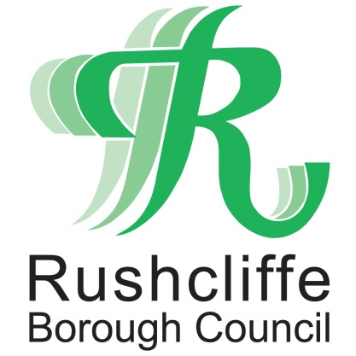 | Press Release

FOR IMMEDIATE RELEASE REF EMAIL
14.08.20
Get your Council news to your inbox!
Rushcliffe Borough Council is launching a new email subscription service that will deliver updates directly to residents’ inboxes.

Residents and businesses can sign up for the updates at: https://bit.ly/RushcliffeSignUp to receive the latest news and information on Council services.

This includes updates on council tax, garden waste collections, leisure centres, events and how to report fly tipping and litter and find out more about planning applications in their neighbourhood.

Updates will initially be weekly and this will be reviewed with more topics introduced as the authority continues to adapt to a post COVID-19 world.

The Council’s Cabinet Portfolio Holder for Business and Economic Growth Cllr Andy Edyvean said: “We are delighted to launch this service so residents can stay even more informed with news and updates on our services.

“We know many residents already engage with us on our website at www.rushcliffe.gov.uk and by our ever growing social media channels but as we have increased digital interaction even more so this year this will be another ideal way they can keep up to speed at the touch of a button.

“We encourage all to subscribe whilst we continue to assess ways to engage hard to reach groups and those who choose to not receive updates digitally.”

Emails will be sent using the GovDelivery service, which is used by more than 300 public sector organisations in the UK and Europe, with over 13 million subscribers.

- ENDS -
NOTE TO EDITORS

For information please contact the Rushcliffe press office on 0115 9148 555 or media@rushcliffe.gov.uk

For the latest news and events, follow @rushcliffe on Twitter or Rushcliffe on Facebook or go to the council's website.

