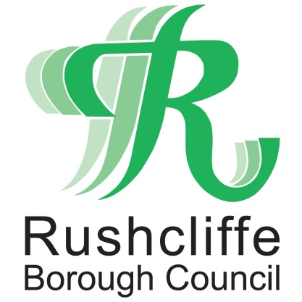 | Press Release

FOR IMMEDIATE RELEASE REF FLY-TIP
14.08.20
Further action to deter rural Rushcliffe fly-tipping

Further action is being taken to deter rogue fly-tippers from blighting landscapes in Gotham, Barton-in-Fabis and Thrumpton and surrounding areas in Rushcliffe.

New bins and signage from Rushcliffe Borough Council now instructs motorists to ‘bin it, don’t dump it’ at lay-bys in the area backing up continued surveillance and monitoring at the sites to catch those who flout the rules.

The new features, installed by Streetwise on behalf of the Council, builds on the work of a wider project which started last month, following an increase in fly-tipping in the area this year with trade waste and household items being dumped in laybys, roads and verges.

The Council, Nottinghamshire Police and Parish Council representatives joined forces in July to stop vehicles on the nearby A453 Remembrance Way, Green Lane and Fox Covert Lane to make checks on trade waste and other drivers.

The partners are working together to combine resources and share information to support even more local action, including surveillance and fly-tip watch groups.

Residents and businesses are reminded to check that any company or individual they employ to dispose of their waste holds the relevant Trade Waste Carriers’ licence to avoid their unwanted goods contributing to fly-tips.

This can be completed by them showing the relevant licence in person and checking it with the Environment Agency’s listings of registered businesses here: https://bit.ly/1UFAWfn

Rushcliffe Borough Council’s ward councillor for the area Cllr Rex Walker joined Thrumpton Parish Meeting Chairman Ben Wilson, Gotham Parish Council Chairman Gill May and Streetwise’s Chairman Dave Mitchell and Managing Director Nigel Carter to view the new facilities at a lay by on Nottingham Road between Clifton and Gotham.

The Council’s Cabinet Portfolio Holder for Neighbourhoods Cllr Rob Inglis said: “The new bins and signs complement the clear message that Rushcliffe Borough Council will not tolerate offenders dumping waste illegally in our picturesque and rural areas.

“Fly-tippers are warned that we are taking this very seriously and by our various monitoring means we will take positive action and prosecute from any evidence gathered and that includes seizing the vehicles involved.

“Residents have a huge part to play too by always checking that anyone they pay to take items away from their home is a registered waste carrier by requesting to view the appropriate Environment Agency licence.”
Cllr Walker added: “The Council’s engagement has been very positive so far since residents, the local parishes and I raised this issue and we’ll continue to look at further ways in which we can work together.
“From signage to surveillance, we are exploring what methods can deter fly-tippers from blighting our rural landscapes.”
Streetwise Chairman Dave Mitchell said: “We’re pleased to be able to support partners wherever we can to reduce fly-tipping across Rushcliffe.

“As we work across the Borough and the region, our teams continue to join communities in being extra eyes and ears in reporting information that can help the authorities take action against those who choose to not dispose of waste legally.”

- ENDS -
NOTE TO EDITORS

For information please contact the Rushcliffe press office on 0115 9148 555 or media@rushcliffe.gov.uk

For the latest news and events, follow @rushcliffe on Twitter or Rushcliffe on Facebook or go to the council's website.

