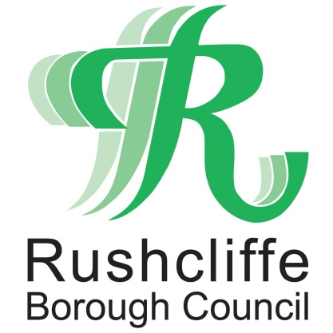 | Press Release

FOR IMMEDIATE RELEASE REF. HOSPITALITY
14.05.21

Council and Police further assist hospitality businesses to safely reopen indoors

Rushcliffe Borough Council and Nottinghamshire Police are actively supporting the hospitality sector reopening indoor spaces again safely across Rushcliffe, with the guidance of an updated fact sheet to help staff further safely welcome back customers.

The guide has now been sent to over 200 premises across the Borough with the vital information government has set out on how to operate in a COVID secure way, as restrictions continue to lift in the coming weeks from Monday May 17.

Available at www.rushcliffe.gov.uk/businesscoronavirus it highlights businesses must continue to collect contact details of all customers or direct them to the Test and Trace QR code on smart phones to log their visit to any outlet.

In line with current guidelines from this Monday food or drink may be consumed inside hospitality businesses but table service must remain in place with social distancing between tables and when using toilets and facilities and booking of a maximum of six people or two households per table.

If the premises does not serve alcohol, customers can order and collect food and drink from a counter however they must consume food and drink while seated.

Customers using the toilet or baby change facilities inside a premises must wear a face covering when doing so.

If the premises does not serve alcohol, customers can order and collect food and drink from a counter however they must consume food and drink while seated.

Rushcliffe Borough Council’s Cabinet Portfolio Holder for Neighbourhoods Cllr Rob Inglis said: “It’s been such a tough time for businesses over the last year and whilst the easing of restrictions last month has helped many, we want to continue our support wherever possible.

“The latest lifting of restrictions should help boost our local cafes, restaurants and bars even further, but we are reminding business owners of their responsibilities.

“This is to ensure they are fully aware of their obligations to operate securely, particularly table service and for all customers to embrace and abide by these guidelines that still need to be in place.

“Our Environmental Health and Licensing teams are ready with assistance and advice every step of the way.”

If businesses or customers have questions or need advice, the teams are on hand with support by emailing envhealth@rushcliffe.gov.uk or calling 0115 981 9911.

No one should enter an outlet if they have any COVID-19 symptoms and in West Bridgford signage will again outline a Public Spaces Protection Order is in place outlining local rules on drinking in public spaces in the town.

- ENDS -

NOTE TO EDITORS

For information please contact the Rushcliffe press office on 0115 9148 555 or media@rushcliffe.gov.uk

For the latest news and events, follow @rushcliffe on Twitter or Rushcliffe on Facebook or go to the council's website.

