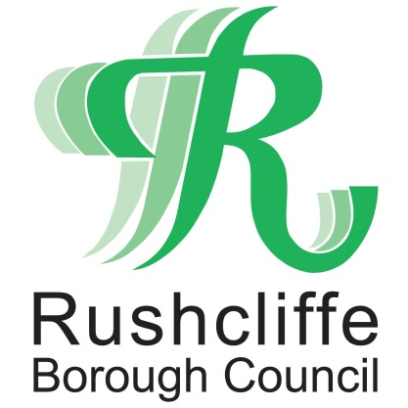 | Press Release

FOR IMMEDIATE RELEASE REF CLEAN
14.05.21

Come and join the Great British Spring Clean and make your local community even tidier

Rushcliffe Borough Council is pledging its support for this year’s Great British Spring Clean, which aims to further clean up the streets, parks and open spaces in Rushcliffe and nationwide.

The annual campaign, run by the charity ‘Keep Britain Tidy’ runs this year from May 28 to June 13 which will see people from all over the UK come together to save the environment as well as keep their local communities clean and safe.

Here in the Borough, the authority is calling on groups and individuals to join the effort and volunteer to litter pick in their community for as little as an hour or however long they can give.

All the necessary COVID secure equipment is available from the Council’s grounds maintenance partners Streetwise Environmental Services Limited by calling 0115 914 8408 or emailing streetwise@streetwiseenvironmental.co.uk

COVID-19 has affected everything over the past year and the Great British Spring Clean is no different.

Therefore, the safety of those who are taking part is paramount and the council is committed to making sure all volunteers are safe.

Rushcliffe Borough Council’s Cabinet Portfolio Holder for Neighbourhoods Cllr Rob Inglis said: “We thank the many volunteers who already litter pick their local communities regularly and help keep our streets, parks and open spaces even tidier.

“There are those who don’t take pride in where they live and blight our towns and villages with rubbish and we continue to work with Waste Investigations Support & Enforcement (WISE) to identify and fine where necessary those who litter or fly-tip.

“Now, with safety in mind, we are asking even more groups and individuals to join the national effort and arrange a litter pick between May 28 and June 13 and help take greater pride in their communities to combat the irresponsible actions of a few.

“We encourage any groups to socially distance in order to maintain safety during any litter pick and all the advice and support you need is available by emailing media@rushcliffe.gov.uk and we thank you in advance for helping make Rushcliffe a great place.”

Teams such as the East Leake Tidy Team are one of the fantastic groups that already work tirelessly on keeping their local community clean and tidy, for all to enjoy.

Group Coordinator Mel Roper said: “We’d encourage groups everywhere to join the Great British Spring Clean.

“We regularly meet to keep our village clean and tidy and it’s become a real social event too where we head to a café or pub afterwards to catch up with our fellow volunteers.

“We’re all passionate about the place where we live and we have people from all ages joining us helping out including local children. It’s really important we do all we can to educate younger generations how important it is to look after the environment wherever we can.”

In addition to the regular clean-up, ‘Keep Britain Tidy’ has launched the #millionmilemission, which aims to clear 1 million miles of waste from the UK, of which over 500,000 miles has already been pledged.

Town and Parish councils are also being contacted and encouraged to take part and help to achieve the milestone.

To find out more about the Great British Spring Clean visit www.keepbritaintidy.org

-ENDS -

NOTE TO EDITORS

For information please contact the Rushcliffe press office on 0115 9148 555 or media@rushcliffe.gov.uk

For the latest news and events, follow @rushcliffe on Twitter or Rushcliffe on Facebook or go to the council's website.

