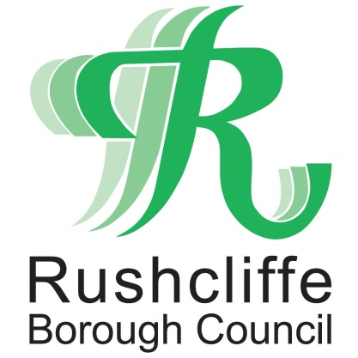 | Press Release

FOR IMMEDIATE RELEASE REF FIVE STEPS
13.06.20

High street businesses in Rushcliffe welcome back customers with five secure steps

Business owners on high streets across Rushcliffe are completing five secure steps to welcome back customers from Monday (June 15).

Rushcliffe Borough Council has been connecting with businesses across the Borough to offer support and is encouraging further premises to review their plans for reopening, in line with Central Government advice, ensuring they’re considering the steps needed to open securely.

In particular, the authority is joining calls for businesses to follow important tasks to be completed before they reopen alongside fellow non-essential retailers.

Once completed, businesses can display the ‘five steps to safer working together’ poster, which lists the pledges they have made to themselves, their employees and their customers as part of their process to reopen responsibly.

This includes undertaking a COVID-19 assessment, introducing appropriate cleaning, handwashing and hygiene procedures in line with Government guidance and taking reasonable steps to help people work from home.

Business owners must also have taken steps to help maintain social distancing in the workplace and have prepared practical methods of managing the transmission risk where this is not possible.

Rushcliffe Borough Council’s Cabinet Portfolio Holder for Business and Transformation Cllr Andy Edyvean has been joining officers from the Economic Growth team to engage with hardworking business owners through webinars and in person to see how businesses are adapting to take the necessary steps to reopen.

He said: “During this exceptionally challenging period, we’re looking to support local business owners across the Borough wherever possible and we’ve been delighted to hear of the plans many are already putting place to open as securely as possible.

“As many businesses in our towns and villages look to reopen, we urge them to ensure they do so responsibly and with a keen awareness for the current guidelines that will work to protect them and their customers.

“Business which have already completed their five steps towards reopening can reassure their customers that they are taking all the necessary precautions to welcome them back with the relevant procedures in place.

“We encourage anyone with uncertainties about the requirements on their business at this time to visit www.rushcliffe.gov.uk/businesscoronavirus and read more about the steps they should be taking before reopening and explore the wide array of support, guidance and practical advice currently available for businesses.”

Teams from the authority are set to visit retail centres from next week to offer further support to businesses as they adapt to any necessary changes to their arrangements.

One business preparing to welcome customers back to their premises is East Leake photography studio Captcha, owned by Hayley Masom.

She said: “It’s been a very tough time as a business owner to adapt our services, but together with other business across East Leake and the Borough we’re looking forward to welcoming our customers back onto the premises following these secure measures.

“The Borough Council have been of great assistance to me and other business owners and we’ll look forward to continuing to work with the authority as we encourage everybody to shop local.”

Residents returning to the high streets from Monday are reminded to play their part by wearing a face mask when visiting businesses and practicing social distancing both inside and outside premises.

- ENDS -
NOTE TO EDITORS

For information please contact the Rushcliffe press office on 0115 9148 555 or media@rushcliffe.gov.uk

For the latest news and events, follow @rushcliffe on Twitter or Rushcliffe on Facebook or go to the council's website.

