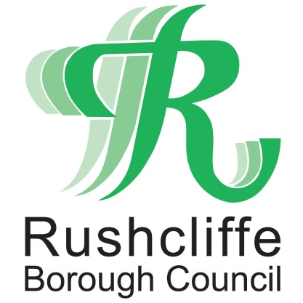 | Press Release

FOR IMMEDIATE RELEASE REF GRANT
12.06.20

Rushcliffe businesses signposted to
online grant finder

Rushcliffe Borough Council is signposting businesses to a new online grant finder to help them search and secure funding and guidance during COVID-19.

The portal at www.idoxopen4business.co.uk/Rushcliffe can help small and medium businesses across the Borough to quickly and easily search for the funding and grants which apply to their individual circumstances.

Regularly updated with new local and regional funding announcements, the database operated by Open 4 Business allows business owners to search for support based on their industry, region or size.

Rushcliffe businesses can also filter through results to find details on how to directly contact the organisations providing the appropriate funding, should they have any queries.

To access the free portal and find the extensive list of search results and guidance, business owners will need to register online via the Open 4 Business website.

Rushcliffe Borough Council’s Cabinet Portfolio Holder for Finance and Contracts Cllr Gordon Moore said: “This online portal provides business owners across the Borough with the essential opportunity to find the right funding for them easily and efficiently.

“COVID-19 has presented our local businesses with many unexpected challenges this year and we want to ensure they all access the support available to help them prepare for welcoming customers again in the near future.”

- ENDS -
NOTE TO EDITORS

For information please contact the Rushcliffe press office on 0115 9148 555 or media@rushcliffe.gov.uk

For the latest news and events, follow @rushcliffe on Twitter or Rushcliffe on Facebook or go to the council's website.

