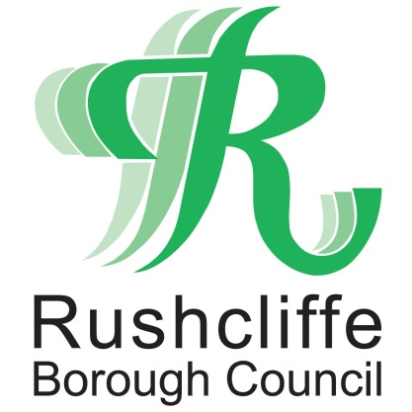 | Press Release

FOR IMMEDIATE RELEASE REF CAR PARKS
12.04.21

Rushcliffe car parks free
after 3pm until further notice

Town and village centre Rushcliffe Borough Council managed car parks are free to use after 3pm until further notice to give a boost to non-essential retail and hospitality that is opening today, April 12.

Motorists can park at Bridgford Road, Gordon Road and Nursery car parks in West Bridgford, Bunny Lane in Keyworth and Needham Street in Bingham where routinely there are charges, for free after this time.

The usual structured daytime parking rules will be in place until 3pm each day to ensure a healthy turnover of spaces to help support local economies in these locations.
Rushcliffe Borough Council’s Executive Manager for Neighbourhoods Dave Banks said: “It’s been incredibly tough times for so many businesses as they have been closed in recent months and we want to support them with this offer with convenient parking for motorists.
“It allows all to park for free after 3pm and give customers even longer to visit their favourite retail outlets, pubs or restaurants that are open again for business.
“We hope residents and visitors take advantage of this free parking to visit our towns and villages to support business owners as they recover from the pandemic.
“Any charges at our car parks are re-invested back into facilities that ensure they are safe and attractive with maintenance on lighting, resurfacing, ticket machines and improvements such as the highly popular RingGo service and electric charging points.”
Signs are now in place highlighting the arrangements for car park users that it is anticipated will be in place for at least four weeks.

Visit www.rushcliffe.gov.uk/carparking for the latest updates on this initiative and all the information you need to park safely across Rushcliffe towns and villages.
- ENDS -

NOTE TO EDITORS

For information please contact the Rushcliffe press office on 0115 9148 555 or media@rushcliffe.gov.uk

For the latest news and events, follow @rushcliffe on Twitter or Rushcliffe on Facebook or go to the council's website.

