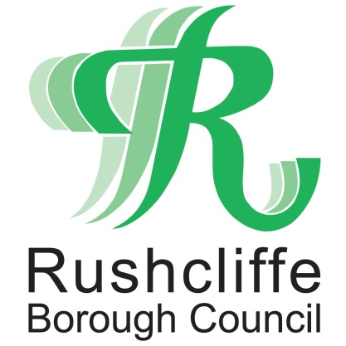 | Press Release

FOR IMMEDIATE RELEASE REF.GRANT
11.11.20

Further COVID-19 business support grants announced for Rushcliffe businesses

Central government has announced a second wave of COVID-19 financial business support for eligible Rushcliffe and Nottinghamshire businesses.

Rushcliffe Borough Council will administer the grants for businesses in the Borough who were affected when they entered Tier 2, Tier 3 and national lockdown restrictions.

Many eligible businesses can now access the discretionary Local Business Support Grant Scheme and other support at www.rushcliffe.gov.uk/businesscoronavirus and information on other business support activities.

Grants will be processed as quickly as possible with business owners asked to ensure all supporting documents are included with any application.

Nottinghamshire Councils have worked together to create a consistent scheme across the County seeking to support those in the non-essential retail, hospitality, leisure and accommodation sectors and those who directly supply them.

These include:
- Bookmakers
- Camping and caravan sites
- Exhibition centres, conference halls and event spaces
- Hotels
- Leisure centres, gyms, yoga or dance centres
- Licensed bars and pub
- Outdoor sporting venues such as golf clubs, stables and riding centres
- Play centres and soft play centres,
- Restaurants and cafes with indoor or outdoor seating,
- Tattoo parlours, tanning salons, spas and beauty services, hair salons and barbers
- Businesses and self-employed business owners operating predominantly in these sectors.

Other grants are also now available for businesses closed in line with national lockdown until December 2, those closed in line with tier 3 restrictions from October 30 to November 5 and businesses that were open in line with tier 2 restrictions from October 14 to November 5.

Leader of Rushcliffe Borough Council Cllr Simon Robinson said: “These vital grants will be distributed to eligible businesses as part of the wider support to the economy as we assist central government in managing the impacts of COVID-19.

“We know businesses everywhere are facing an incredibly tough position. Our teams will work hard with business owners to ensure the grants can reach them as soon as possible.

“It follows over £19 million of grants being distributed in the first lockdown earlier this year.”

- ENDS -

NOTE TO EDITORS

For information please contact the Rushcliffe press office on 0115 9148 555 or media@rushcliffe.gov.uk

For the latest news and events, follow @rushcliffe on Twitter or Rushcliffe on Facebook or go to the council's website.

