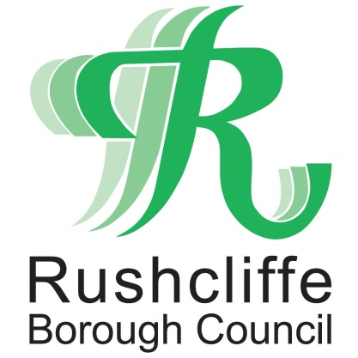 | Press Release

FOR IMMEDIATE RELEASE REF TREE
11.10.21
Free tree scheme returns for Rushcliffe residents!

Rushcliffe residents can make their properties even greener by applying for free trees for a fourth year running.

Over 8,000 trees have been distributed since the start of the campaign in 2018 and now 800 wild cherry and dogwood trees are available without charge.

It’s part of Rushcliffe Borough Council’s strategy to provide sustainable environments in line with the Borough’s significant housing and employment growth in the coming years.

Householders are encouraged to apply as soon as possible given anticipated high demand and can apply for up to two trees by visiting https://www.surveymonkey.co.uk/r/FreeTrees2021 and submitting an application before October 31.

The Council’s Cabinet Portfolio Holder for Communities and Climate Change Cllr Abby Brennan said: “We are delighted to be running the free tree scheme again, after a wonderful response from residents since the scheme was launched in 2018.

“They have shown great enthusiasm in collecting and planting thousands of these free trees and we thank them for their continued support to making Rushcliffe a great and greener place to live.

“We hope that by increasing the number of trees in the Borough, our green environments will grow alongside our communities, improving the quality of life for both current and future residents.”

Successful applicants will have trees delivered direct to their door by Streetwise with the volume of delivery trips minimised by the firm to make its carbon footprint as low as possible.

The Wild Cherry or Prunus avium can grow to 25 metres tall, flowers in spring and fruit in summer and autumn colour. They like full sunlight and fertile soil but do not tolerate waterlogged soil.

The Dogwood or Cornus sanguinea trees grow to 10 metres tall, has creamy flowers followed by black berries and crimson autumn leaves. It is a shade-tolerant tree and can cope with damp conditions.

- ENDS –

NOTE TO EDITORS

For information please contact the Rushcliffe press office on 0115 9148 555 or media@rushcliffe.gov.uk

For the latest news and events, follow @rushcliffe on Twitter or Rushcliffe on Facebook or go to the council's website.

