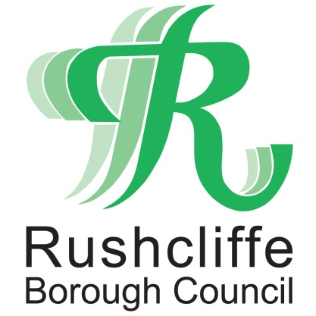 | Press Release

FOR IMMEDIATE RELEASE REF. REACH
10.11.20

Reach Rushcliffe funding helps charity to support socially isolated residents in Bingham

A charity in Bingham has received vital funding from Reach Rushcliffe to help volunteers connect with socially isolated residents and provide them with food, support and social contact.

The Rosie May Foundation has received funds as part of Rushcliffe Borough Council’s initiative to tackle social isolation and loneliness, which launched earlier this year.

The Foundation has already utilised the funds to help with its ongoing work within the local community and to assist vulnerable residents who may be facing additional challenges due to COVID-19.

The support has helped volunteers continue their regular activities to tackle social isolation, such as Fish and Chip Fridays, where volunteers deliver the popular supper in pink Tuk Tuks to elderly members of the community.

Providing more than just a tasty meal, these regular activities keep volunteers from the Rosie May Foundation in touch with members of the community who might otherwise enjoy little social interaction during the week.

The project is one of nine successful applications that have benefitted from over £14,000 to help those in need under Reach Rushcliffe.

Rushcliffe Borough Council’s Cabinet Portfolio Holder for Community and The Environment Cllr Abby Brennan praised the charity’s tireless efforts to reduce loneliness and social isolation during such uncertain times.

Cllr Brennan said: “I’m delighted that Reach Rushcliffe has been able to support yet another fantastic organisation in their efforts to keep our communities happy, healthy and whole.
“During times when regular social interaction can be difficult for some members of our local towns and villages, the Rosie May Foundation is undertaking vital work to connect with people and make sure their voices are heard.

“As we all continue to support one another through the pandemic, I hope the little pink Tuk Tuk remains a regular reassuring sight on the streets of Bingham and a reminder of the generosity, resilience and kindness of our great local organisations.”

Mary Storrie, Founder of the Rosie May Foundation said: “During lockdown Rosie the little pink Tuk Tuk was delivering medication and vital food supplies to those in need of additional support.

“Our work has now evolved to focus on increasing social interaction during COVID-19, introducing a simple doorstep chat into our regular visits for anyone who wants to talk.

“The funding from Reach Rushcliffe has been hugely appreciated and will help our volunteers continue to connect with those who place a high value on their weekly catchups, food deliveries and essential link to our charity.”

- ENDS -

NOTE TO EDITORS

For information please contact the Rushcliffe press office on 0115 9148 555 or media@rushcliffe.gov.uk

For the latest news and events, follow @rushcliffe on Twitter or Rushcliffe on Facebook or go to the council's website.

