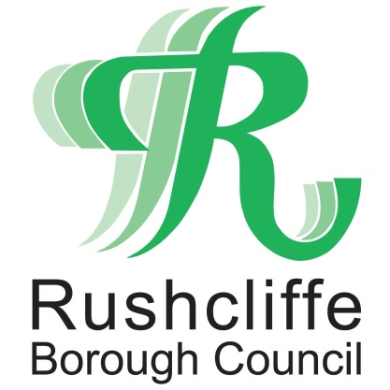 | Press Release

FOR IMMEDIATE RELEASE REF TREE
10.09.20
Free tree scheme returns for Rushcliffe residents, town and parish councils and groups!

Rushcliffe based residents, town and parish councils and groups can make their properties and communities even greener by applying for free trees for a third year running.

Over 5,700 trees have been distributed since the start of the campaign in 2018 and
crab apple and hazel trees are again available without charge.

It’s part of Rushcliffe Borough Council’s strategy to provide sustainable environments in line with the Borough’s significant housing and employment growth in the next decade.

Households can apply for up to two trees by visiting http://bit.ly/TreeScheme2020 and submitting an application before September 30.

Deputy Leader and Cabinet Portfolio Holder for Community and The Environment Cllr Debbie Mason said: “We are delighted to be running this scheme again, after a brilliant response from residents and groups in previous years.

“They have shown wonderful enthusiasm in collecting and planting thousands of these free trees and we thank them for their continued support to making Rushcliffe a great and greener place to live.

“We hope that by increasing the number of trees in the Borough, our green environments will grow alongside our communities, improving the quality of life for both current and future residents.”

Successful applicants will be able to collect the trees from the Council in the autumn adhering to Covid-19 controls and social distancing and will be contacted directly as to when dates will be available.

The crab apple, or Malus Sylvestris, can grow to 12 metres and suit areas of partial shade, whilst hazel trees, or Corylus Avellane, are shade tolerant and can also reach up to 12 metres.

The Council are also offering to supply and plant up to 10 trees per parish this autumn and winter, on land identified by Parish Councils with the owner’s permission. Residents can find out more information on these locations by emailing media@rushcliffe.gov.uk

- ENDS –

NOTE TO EDITORS

For information please contact the Rushcliffe press office on 0115 9148 555 or media@rushcliffe.gov.uk

For the latest news and events, follow @rushcliffe on Twitter or Rushcliffe on Facebook or go to the council's website.

