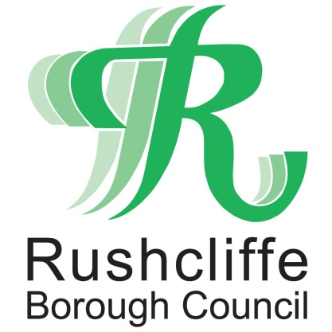 | Press Release

FOR IMMEDIATE RELEASE REF. REACH
10.06.20

Rushcliffe Borough Council works with local organisations to deliver care packages to vulnerable residents
Rushcliffe Borough Council is working with local organisations to deliver care packages to vulnerable residents who are currently self-isolating during COVID-19.

The Council has partnered with Metropolitan Housing, Trent Bridge Community Trust, Nottinghamshire Children’s Centre Service and the Nottinghamshire Coronavirus Community Support Hub to identify those who may be at risk of loneliness or social isolation in the Borough.

The care packages have been developed as part of Reach Rushcliffe, an initiative to tackle social isolation and loneliness, and contain seated and resistance band exercise routines, store cupboard recipe ideas and card games as well as fun activities for adults and families with children.

Deputy Leader of the Council Cllr Debbie Mason said: “We know that it can be incredibly difficult for residents who are self-isolating during this time but we’re delighted that we can assist through our Reach Rushcliffe programme and connect with local organisations to identify and help those in need.

“The packages will help vulnerable residents and families to stay active within their home as well as giving them ideas for tasty recipes with ingredients they may already have and activities to help keep their time and mind occupied.

“We would like to remind anyone who needs support at home to contact Nottinghamshire County Council’s Community Hub on 0300 500 80 80.”
Organisations also looking to reduce social isolation in their part of Rushcliffe can apply for funding through Reach Rushcliffe by visiting https://www.rushcliffe.gov.uk/health/reachrushcliffe/

The exercise cards, recipes and card games can also be downloaded from the same webpage.

- ENDS -

NOTE TO EDITORS
For information please contact the Rushcliffe press office on 0115 9148 555 or media@rushcliffe.gov.uk

For the latest news and events, follow @rushcliffe on Twitter or Rushcliffe on Facebook or go to the council's website.

