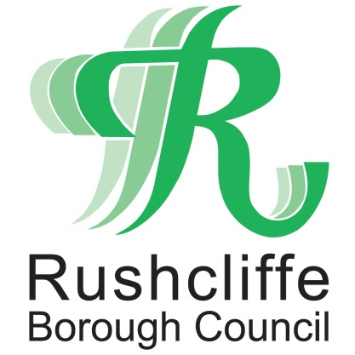 | Press Release

FOR IMMEDIATE RELEASE REF LITTER
10.03.21
Streetwise praises litter-picking sisters
for raising over £2,000 for charity

Two litter-picking sisters who completed a ten-day challenge to make their local area litter free whilst also raising money for charity have been praised by Streetwise Environmental.

Eight-year-old Alice and six-year-old Emily spent an hour every day of their half-term litter picking in West Bridgford whilst attempting to raise £100 for the Alzheimer’s Society.

Such was the success of their project and the inspiration it brought to others, they raised over twenty times their target, collecting £2,030 for the charity.

Streetwise, Rushcliffe Borough Council’s partner grounds maintenance firm, heard about the sisters’ efforts and have now gifted both Alice and Emily a £20 book voucher each for their work.

Sue Harvey, Business Development Manager at Streetwise met the sisters and their parents, Hannah and Jason, at Bridgford Park in West Bridgford to safely hand over their vouchers and to thank them for their efforts.

Sue said: “It was lovely to meet Emily and Alice and to present them with their book voucher to say thank you for such fabulous work, they’ve made a real impact on the environment in their local community.

“We hope they enjoy reading the books they choose and we’re sure that the money raised will be incredibly useful for such a great cause.”
Hannah added: “We’re really proud of Alice and Emily both for the impact they've had on the community and the phenomenal sum of money they have raised to support dementia sufferers and their families. It goes to show that you really are never too small to make a big difference.
“Charities have struggled during the lockdown, with events being cancelled and charity shops closing, yet at a time when support services are more in demand than ever. The funds raised will have a really meaningful impact.
“The girls are really honoured to have been recognised by Streetwise for their efforts. They both love to read and have missed being able to go into a book shop or our fantastic local library to pick up a book to take home. They are delighted with their book tokens and look forward to spending them when restrictions lift.”

Rushcliffe Borough Council’s Cabinet Portfolio Holder for Community and the Environment Cllr Abby Brennan said: “The work that Emily and Alice have been doing is brilliant and they’ve exceeded their initial target by a huge amount - which is fantastic!
“We’re delighted to be able to help them with their litter picking sessions and that Streetwise were able to give them a token of our appreciation for such great work.
“It’s really inspiring to see young people get involved with efforts to keep their part of the Borough tidy and also raise the profile of a national charity that is close to their family’s hearts.”
Anyone wishing to make their area of Rushcliffe even tidier by litter-picking can contact Streetwise by calling 0115 914 8408 or by emailing streetwise@streetwiseenvironmental.co.uk.

- ENDS -

NOTE TO EDITORS

For information please contact the Rushcliffe press office on 0115 9148 555 or media@rushcliffe.gov.uk

For the latest news and events, follow @rushcliffe on Twitter or Rushcliffe on Facebook or go to the council's website.

