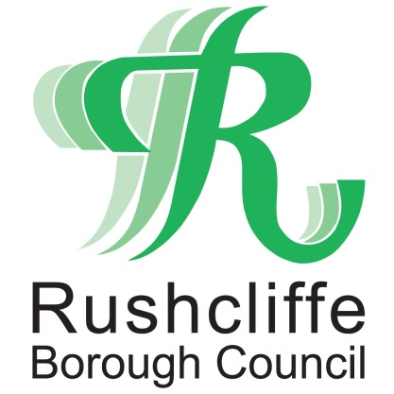 | Press Release

FOR IMMEDIATE RELEASE REF JAB
09.08.21
Rushcliffe residents reminded to ‘Grab A Jab’ and get first or second COVID-19 dose

Residents across Rushcliffe are being reminded to ‘Grab A Jab’ if they are yet to receive their first or second dose of a COVID-19 vaccination, through leaflets being distributed by Rushcliffe Borough Council’s waste team.

Householders in the Borough have engaged well with the programme to date as over 88% of residents have received a first jab.

In conjunction with the local NHS, the teams will be distributing the further messaging to selected neighbourhoods in the coming days and weeks.

Residents in Sutton Bonington, Keyworth, Cotgrave, Ruddington, East Leake and the Trent Bridge and Lutterell wards of West Bridgford will receive the information following slightly lower uptake of the vaccine in these areas.

However figures are only slightly lower when compared with all other areas of Rushcliffe and not linked to any higher number of COVID-19 cases in any locality.

Leader of Rushcliffe Borough Council Cllr Simon Robinson said: “Thank you to everyone who has already received both doses of the vaccine and played their part in protecting each other from COVID-19.

“We continue to encourage all residents to receive the vaccine, including those within three months of their 18th birthday, as confirmed by the NHS locally in the past week.

“We know vaccine uptake across the Borough is good but we want as many people as possible to receive this vital vaccination and continue to help lower COVID cases and hospitalisations and this extra push in some of our communities we hope will lead to many more grabbing a jab.

“Simply call 119 or visit nhs.uk/covid19vaccine to book a jab.”

- ENDS -

NOTE TO EDITORS

For information please contact the Rushcliffe press office on 0115 9148 555 or media@rushcliffe.gov.uk

For the latest news and events, follow @rushcliffe on Twitter or Rushcliffe on Facebook or go to the council's website.

