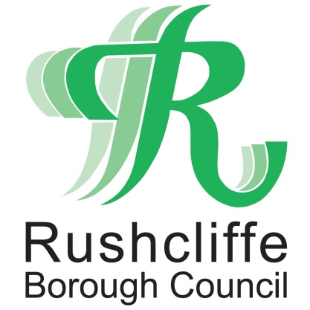 | Press Release

FOR IMMEDIATE RELEASE REF. TESTING
09.08.21

Rapid community testing site to be available in East Leake between August 10 and 12

A rapid mobile community COVID-19 mobile testing unit will be in Gotham Road car park in East Leake from Tuesday August 10 to Thursday August 12 from 9am to 3pm each day providing residents with access to on the spot tests or lateral flow tests to complete at home.

No appointments are necessary at the testing sites and visitors will simply be asked to register to get their results whilst the lateral flow tests can be collected quickly and easily.

Around one in three people infected with COVID-19 show no symptoms at all and could potentially spread the disease without knowing it.

The tests on site only take a few seconds and results are delivered within 60 minutes directly to a smartphone. The test is designed to identify anyone who may have the virus and who may be, unwittingly, putting their colleagues or households at risk.
A reminder also that those who within three months of their 18th birthday can now receive a vaccination by walking into any vaccination site in Nottinghamshire for a COVID-19 jab.
Those 18 and over, can also get a vaccine without an appointment and those who have had their first dose 56 days ago (eight weeks) can walk in for their second dose.
You do not need to be registered with a GP or bring any ID but it will help to bring your NHS number, if you know it.
Find out more at www.rushcliffe.gov.uk/communitytesting

Remember get a PCR test as soon as possible if you have any of these symptoms, even if mild:
- a high temperature
- a new, continuous cough
- a loss or change to your sense of smell or taste
You and anyone you live with should stay at home until you get your test result. Only leave your home to have a test which can be booked at https://www.gov.uk/get-coronavirus-test
- ENDS -

NOTE TO EDITORS
For information please contact the Rushcliffe press office on 0115 9148 555 or media@rushcliffe.gov.uk

For the latest news and events, follow @rushcliffe on Twitter or Rushcliffe on Facebook or go to the council's website.

