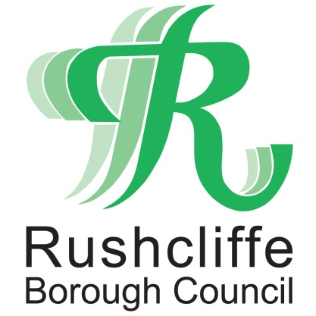 | Press Release

FOR IMMEDIATE RELEASE REF AWARD 09.06.21

Rushcliffe Borough Council shortlisted for national award for speed of vital COVID-19 grants to businesses

Rushcliffe Borough Council’s Finance and Revenues teams have been shortlisted for a national award for reaching out to local businesses quickly and effectively during COVID-19 distributing vital central government grant funding.

The authority will now be in the running for a CCLA/Room151 Impact Award that have seen thousands of the grants administered with speed and accuracy.

The Council’s section 151 Officer and Deputy Chief Executive Peter Linfield, Finance Service Manager Sarah Whittaker and Revenues Manager Rob Cottee were key to developing a scheme across the Borough which enabled the grants to be distributed from as soon as funds were made available.

It involved a pressured challenge to quickly identify appropriate criteria, create a secure method to identify eligible applicants and notify them that they could claim and receive the vital funds they needed to help them stay afloat

Rushcliffe Borough Council’s Cabinet Portfolio Holder for Finance and Customer Access Cllr Gordon Moore said: “The teams were already stretched with year-end procedures and annual billing in April 2020 but demonstrated incredible resilience, teamwork and commitment to ensure these payments reached businesses when they needed them most.

“They knew when the pandemic hit it was so many people’s livelihoods were potentially at stake and their work over the last 15 months was not just a one-off but direct from the culture embedded in the teams to all take responsibility and act quickly and effectively.

.

“Managing the impact of the pandemic whilst protecting the public purse will be one of the legacies of COVID-19 here at Rushcliffe along with staff demonstrating they are willing to do whatever it takes and go that extra mile.”

All Rushcliffe businesses can still access COVID-19 related support at www.rushcliffe.gov.uk/businesscoronavirus that includes business support programmes with workshops and one to one coaching on marketing and shopper experience.

ENDS

NOTE TO EDITORS

For information please contact the Rushcliffe press office on 0115 9148 555 or media@rushcliffe.gov.uk

For the latest news and events, follow @rushcliffe on Twitter or Rushcliffe on Facebook or go to the council's website.

