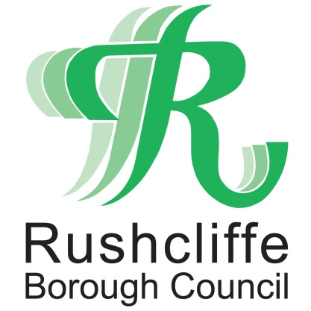 | Press Release

FOR IMMEDIATE RELEASE REF. REACH
08.07.20

Reach Rushcliffe funding helps
walking group to combat social isolation

A walking group that helps to combat social isolation and loneliness has received vital funding from Reach Rushcliffe.

Rushcliffe Ramblers is receiving funds as part of Rushcliffe Borough Council’s initiative which was launched in May aiming to tackle the issues.

The group will use the funds to encourage more participants to join their health walks, which are aimed at residents recovering from illness, with low self-esteem, who have poor physical health or are socially isolated, as well as to the Ramblers’ general sessions for those who enjoy walking and socialising.

The project is one of six successful applications that have benefitted from over £8,000 to help those in need.

Rushcliffe Ramblers will also use the funding to purchase leaflets, allowing them to extend and promote their group to more residents.

Deputy Leader of the Council Cllr Debbie Mason met Rushcliffe Ramblers’ committee member Trevor Griffiths at the starting point of one of their frequent walking routes.

Cllr Mason said: “It is brilliant to award funding to another local organisation, which will help them to reach more residents at risk of health conditions or social isolation as well as helping them to reap the benefits of getting out into the fresh air.

“We know that exercise is incredibly important and especially to those with health conditions or at risk of being disconnected to their community, with this group also adding a social aspect so members can meet new people and walk together.
“We would encourage any organisations also looking to reduce social isolation in their part of Rushcliffe to apply for funding through Reach Rushcliffe by visiting www.rushcliffe.gov.uk/health/reachrushcliffe/.”

Mr Griffiths said: “It is great to receive funding through Reach Rushcliffe and the Borough Council as we can now extend our group to reach more residents across the Borough.

“Our health walks especially help those who may have been ill or struggling with their mental health, so to be able to promote that further is fantastic.”

- ENDS -

NOTE TO EDITORS
For information please contact the Rushcliffe press office on 0115 9148 555 or media@rushcliffe.gov.uk

For the latest news and events, follow @rushcliffe on Twitter or Rushcliffe on Facebook or go to the council's website.

