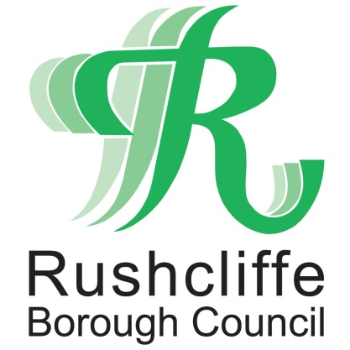 | Press Release

FOR IMMEDIATE RELEASE REF CENSUS
08.02.21
Working together to deliver
a successful Census 2021

The Office for National Statistics (ONS) – which runs Census 2021 – is working with Rushcliffe Borough Council to deliver a successful census and help local services to fully meet future needs.

Understanding the needs of the nation helps everyone from central government to local organisations, such as councils and health authorities, plan and fund public services across England and Wales.

Census outputs inform where public funding is spent on services like transport, education and health – on cycle routes, schools and dental surgeries.

The census, taking place on 21 March 2021, will shed light on the needs of different groups and communities, and the inequalities people are experiencing, ensuring the big decisions facing the country following the coronavirus pandemic and EU exit are based on the best information possible.

Rushcliffe resident, Leia Morales, has been employed by the ONS as a Census Engagement Manager.

She said: “It has been amazing over the last few months to get to know many of the community groups and charities in Rushcliffe and working with the council to raise awareness of Census 2021. I’m looking forward to the data being published next year.”

The Council's Cabinet Portfolio Holder for Community and The Environment Cllr Abby Brennan said: "Households will begin receiving letters with online codes in March explaining how they can complete their online census. People can also request a paper questionnaire if they’d prefer to complete the census that way.

"In areas where lower online completion is expected, around 10% of households will receive a traditional paper form through the post.

"There is plenty of help available, with people also able to complete the census over the phone with assistance from trained staff via the ONS’ free phone contact centre. The ONS also aims to provide in-person support to complete the census online through Census Support Centres where it is safe to do so."

The main census field operation will begin only after Census Day, contacting those who have not responded.

Field staff will never need to enter people’s houses; they will always be socially distanced, wear PPE and work in line with all government guidance. They will be operating in the same way as a postal or food delivery visit.

Census 2021 will include questions about your sex, age, work, health, education, household size and ethnicity. And, for the first time, there will be a question asking people whether they have served in the armed forces, as well as voluntary questions for those aged 16 and over on sexual orientation and gender identity.

Results will be available in 12 months, although personal records will be locked away for 100 years, kept safe for future generations.

For more information and advice on how to answer the questions, visit census.gov.uk.

- ENDS -

NOTE TO EDITORS

For information please contact the Rushcliffe press office on 0115 9148 555 or media@rushcliffe.gov.uk

For the latest news and events, follow @rushcliffe on Twitter or Rushcliffe on Facebook or go to the council's website.

