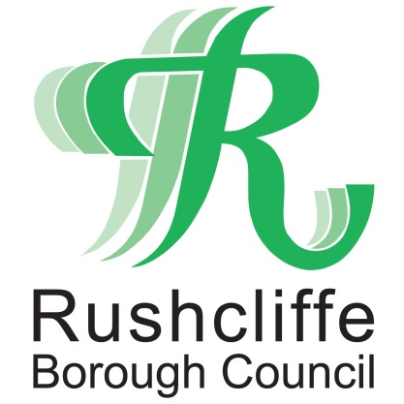 | Press Release

FOR IMMEDIATE RELEASE REF. FLY-TIP
08.01.21

New partnership to further tackle fly-tipping, littering and dog fouling in Rushcliffe
There’s set to be even more focus on tackling the nuisance of fly-tipping, waste offences, littering and dog fouling in Rushcliffe in 2021, thanks to a new partnership.
Rushcliffe Borough Council has teamed up with Waste Investigations Support & Enforcement (WISE) for a one-year trial to build on their existing tools to find and where necessary prosecute those who flout the rules.

From Tuesday (January 5) the new Enforcement Officers have had the powers to issue fixed penalty notices to anyone found contravening the rules, which includes businesses or members of the public.

It’s already seen 14 fixed penalty notices issued for littering across the Borough in its first few days, four fines for fly-tipping, a further 18 fly-tipping complaints investigated and over 20 businesses checked for their commercial waste arrangements.

Their environmental enforcement service will operate across the Borough and will see them look to clamp down on dumped domestic and commercial waste seven days a week and investigate where the waste has come from.

They will be targeting those who don’t dispose of their waste in a responsible way, or hand it over to non-registered waste carriers or create eyesores through dropping litter or failing to pick up after their dog’s waste.

Anyone caught fly-tipping can be issued with a £400 Fixed Penalty Notice or if they are observed littering or failing to pick up after their dog’s waste, will be issued with an on the spot £100 fine.

Failure to pay a Fixed Penalty Notice may result in prosecution being brought and a much higher fine being imposed by the Court as well as a potential criminal record.
Rushcliffe Borough Council’s Cabinet Portfolio Holder for Neighbourhoods Councillor Rob Inglis met Councillor Rex Walker from the Gotham ward in Thrumpton, one location that has suffered fly-tipping issues, and WISE representatives to chat over the initiative.

He said: “Fly-tipping, littering and dog mess is a real frustration for residents.
“At the heart of this issue is a need to tackle that minority of people who still believe it is okay to just dump their rubbish wherever they fancy.

“Dumping waste is anti-social behaviour and impacts on our environment. There is never an excuse to mess up our Borough in this way.

“Working with WISE, their dedicated environmental crime officers will now be out there seven days a week issuing on the spot fines to those who are caught in the act or being traced back to them when items are found tipped.”

WISE are a specialist supplier of environmental crime services to councils across the UK.

Managing Director John Dunne said: “We are pleased to be working in partnership with Rushcliffe Borough Council.

“WISE deliver a wide range of environmental investigations and enforcement services on a national basis and have consequently contributed to a reduction in fly- tipping and the associated cost of cleaning up dumped waste as a result of our efforts.

“Our aim is to reduce environmental crime for the long term and patrol the area in an ‘intelligence led’ manner focusing our controls on identified hotspots received from the complaints and feedback of the general public.

“We will operate a robust but always proportionate methodology to tackle environmental crime, using a wide range of technical support including wireless body worn cameras and a handheld computer which will confirm the identity of an alleged offender before issuing a fixed penalty notice.

“Our officers have been instructed to communicate openly with the community with the overall aim of inclusivity for the Rushcliffe community to play their part in the task ahead.”

- ENDS -

NOTE TO EDITORS

For information please contact the Rushcliffe press office on 0115 9148 555 or media@rushcliffe.gov.uk

For the latest news and events, follow @rushcliffe on Twitter or Rushcliffe on Facebook or go to the council's website.

