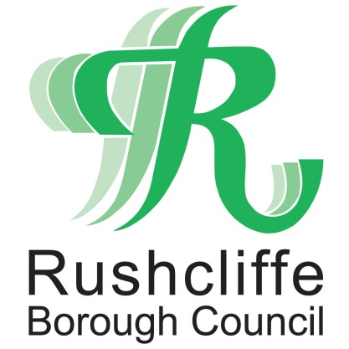 | Press Release

FOR IMMEDIATE RELEASE REF. PENALTY
07.10.20

Ruddington pub fined for holding birthday party with 34 guests in breach of COVID-19 rules

A public house in Ruddington has received a £1,000 fixed penalty notice for breaching COVID-19 rules after accepting a booking of 34 people for a birthday party celebration.

Rushcliffe Borough Council fined The White Horse for hosting the booking of more than six people on September 26, contravening current restrictions for the hospitality industry.
The business admitted the error and paid the fine within 14 days, reducing it to £500, having initially refused an enquiry to host 72 at the event but still accepted 34 attending.
The authority continues to work closely with bar, restaurant and hospitality business owners across the Borough to advise and support on central government guidelines to operate in a COVID secure environment including collecting customer details for track and trace purposes.
It has visited over 230 hospitality businesses in recent weeks to help business owners adapt to new laws and written to all its licensed premises on how they can receive support.
Rushcliffe Borough Council’s Cabinet Portfolio Holder for Neighbourhoods Cllr Rob Inglis said: “This was an exceptionally disappointing occurrence that an error of this magnitude could be made and left us with no option but to serve the fine.
“It’s so tough for businesses currently, we want to support them wherever we can to operate but the rules have been simplified and we will not tolerate complacency when it comes to regulations that are designed to protect the health of our residents.
“The vast majority of business owners across Rushcliffe are taking their responsibilities around COVID operating very seriously and with the current rise in cases in Nottinghamshire it is vital all play their part.
“It’s hugely important that businesses remain diligent and implement all necessary measures to keep their premises secure for customers and help tackle the rising number of cases.”
The wider support for all business owners is continually updated at www.rushcliffe.gov.uk and currently there should be no more than six people at a table, only table service is permitted with no service in bar areas and consumers should not mix between tables.
The Council are asking residents to play their part by downloading the app when they visit hospitality and public venues at https://www.nhs.uk/apps-library/nhs-covid-19/
The information being recorded at each site should include:
- name of each person in the party
- contact number
- date of visit
- arrival time
- departure time, if possible

They are also asked to ensure a member of staff at each premise always asks for details, or if they are not requested, to inform the authority by emailing envhealth@rushcliffe.gov.uk
- ENDS -

NOTE TO EDITORS
For information please contact the Rushcliffe press office on 0115 9148 555 or media@rushcliffe.gov.uk

For the latest news and events, follow @rushcliffe on Twitter or Rushcliffe on Facebook or go to the council's website.

