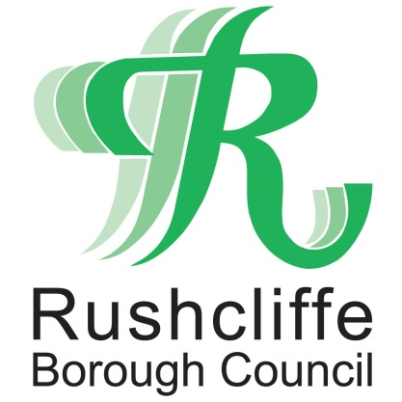 | Press Release

FOR IMMEDIATE RELEASE REF. COVID
07.10.20

Nottinghamshire Councils urge people to follow stricter guidelines on COVID-19

County, district and borough councils are working together and have added their support to the City Council to urge people to follow stricter guidelines to help stop the spread of COVID-19.

It follows a dramatic increase in positive cases of COVID-19 across Nottingham and Nottinghamshire as well as a rise in the rate of infection.

The rates across the county currently vary between 53 and 150 per 100,000. The rate of infection for Nottinghamshire County is 106 per 100,000. Coupled with the alarming rates of infection in Nottingham City which currently sits at more than 400 per 100,000.

All councils in Nottinghamshire are now asking the public to act now. The government’s threshold for concerns is currently 80 per 100,000. Therefore, all the county districts and boroughs are likely to be the subject of additional restrictions and measures.

The Government is expected to announce tougher restrictions for Nottingham and Nottinghamshire later this week which could include measures similar to those in place in other parts of the country in which movements are restricted.

The County Council and district councils are working alongside the City Council in urging people to take urgent steps now to not mix indoors with people from other households.
Director of Public Health for Nottinghamshire Jonathan Gribbin said: “COVID-19 does not recognise geographical boundaries so we must stand together with our local authority partners to do all we can to fight this virus across all our communities.
“The rapid and sustained increase in the numbers of positive cases is a serious cause for concern and the very dramatic rates in the city are a clear sign that action is needed now across the whole of Nottingham and Nottinghamshire.
“We must now ask every resident to do their bit and not mix indoors with people from other households.
“It is critical that if you have symptoms of COVID-19 – high temperature, continuous cough or loss of taste or smell – to self-isolate immediately and book a test by calling 119 or by going online to gov.uk. Please do not go to A&E or call your GP to get a test.
“And I wholly support calls from the director of public health for Nottingham to strongly advise people, anywhere in Nottinghamshire, to remain in their social bubbles and not mix in their homes with people from other households.
“Despite the efforts of our best scientists the fact remains there is no vaccine for COVID-19 at present. The single best way to suppress the spread of the virus is in all of our hands.
“This is through effective handwashing, wearing a face covering where needed, and maintaining a distance of at least two metres where possible. Get tested if you have symptoms, then self-isolate and follow the advice when the results are given.”
Leader of Rushcliffe Borough Council Cllr Simon Robinson said: “It’s imperative Rushcliffe residents, in line with all those across Nottinghamshire, play their part to stop the spread of the virus by not mixing indoors with people from other households.

“We know the sacrifices many people have made and continue to make that affect their freedom but we must continue to follow all guidelines so we can do what is required to protect us all.

“Please continue to check our website www.rushcliffe.gov.uk for the latest advice to follow.”

Director of Adult Social Care for Nottinghamshire County Council Melanie Brooks said:” We are advising Care Homes to restrict visiting to exceptional circumstances only.

“We thank carers and relatives for their patience as we work to protect those most at risk of adverse consequences of COVID-19. Please contact care homes to ask about their specific restrictions before you visit. We appreciate how hard these new restrictions will be, but we must prioritise the safety of our residents and workforce.”

- ENDS -

NOTE TO EDITORS
For information please contact the Rushcliffe press office on 0115 9148 555 or media@rushcliffe.gov.uk

For the latest news and events, follow @rushcliffe on Twitter or Rushcliffe on Facebook or go to the council's website.

