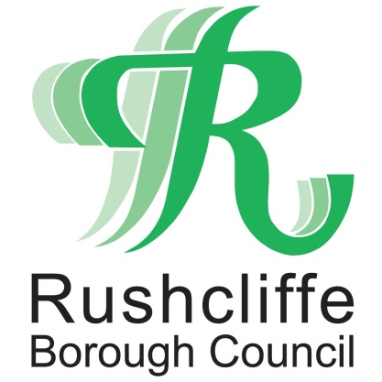 | Press Release

FOR IMMEDIATE RELEASE REF SKATE
07.08.21
Free beginners and women and girls skateboarding sessions at Rushcliffe Country Park’s new skate park!

Skate Nottingham are providing free skateboarding sessions for beginners and women and girls at Rushcliffe Country Park’s new skate park as part of official opening celebrations on Saturday August 14.

Anyone looking to get involved can borrow a skate board and helmet for the session from 9.30am to 10.30am which can be booked here https://bit.ly/3yyJJXW or those aged eight and over can bring their own skating equipment along to the session.

Further activities will take place from 10.30am for women, girls, including non-binary or LGBTQ+, with instructors on hand for guidance and then all BMX and wheeled sports are invited to join from 11.30am.
The £210,000 skate park opened in June, perfectly timed to capture the legacy of great achievements by Britain’s skateboarding and BMX athletes at Tokyo’s 2020 Olympics and was funded by Rushcliffe Borough Council and supported by Skate Nottingham, Canvas Spaces, and VIA East Midlands.
Prizes will also be awarded for various achievements, from beginner level through to advanced!
The Council’s Cabinet Portfolio Holder for Communities and Climate Change Cllr Abby Brennan said: “We are delighted that Skate Nottingham are offering coaching and guidance sessions as part of the official opening celebrations, giving younger and older skaters alike a chance to have a go at the sport.
“The brilliant new skate park has received great reactions so far from both our partners in the project and skaters and BMXers alike. We’d love for any residents or visitors to come along and give skateboarding a try!
“We are formally celebrating this great new facility this Saturday, in line with COVID-19 restrictions lifting in recent weeks and hope everyone can join us for a fun morning and afternoon.”
The facility replaced the former wooden structure which was in need of refurbishment and the Council developed the project alongside Skate Nottingham, science education charity Ignite! Futures and Nottingham Trent University.
Skate Nottingham’s instructors will sanitise all the equipment before and after the sessions and where the coaches need to have contact with a participant in order to reduce their risk of falling, they will sanitise their hands before and after and will wear a mask in case of prolonged proximity.
Skate Nottingham also request that those attending wear appropriate footwear such as trainers, running shoes or plimsolls and parents or carers are requested to not go onto the skatepark area during the lesson.
- ENDS -
NOTE TO EDITORS

For information please contact the Rushcliffe press office on 0115 9148 555 or media@rushcliffe.gov.uk

For the latest news and events, follow @rushcliffe on Twitter or Rushcliffe on Facebook or go to the council's website.

