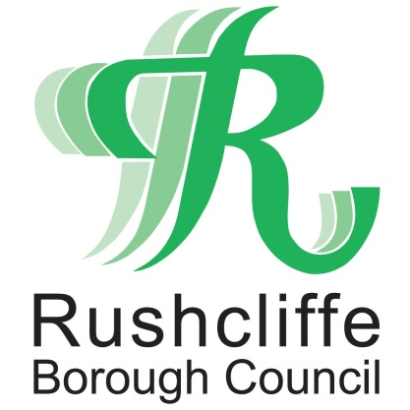 | Press Release

FOR IMMEDIATE RELEASE REF RECYCLE
06.08.21
Pringles tubes, coffee and hot chocolate containers now accepted at Rushcliffe recycling bring sites

Rushcliffe residents can now recycle Pringles tubes, coffee and hot chocolate tubs with metal ends at Tetra Pak recycling facilities at local bring banks across the Borough.

These new items also including croissant dough cans can now be recycled in the dedicated bring banks in addition to orange juice, chopped tomato and milk cartons and soya milk and custard Tetra Pak items.

It’s part of Rushcliffe Borough Council’s new partnership with the Alliance for Beverage Cartons and the Environment (ACE UK), which means that the items can be deposited at the sites instead of being placed in the grey bin at home.

Local residents can now recycle these containers at locations across the Borough, which can be found at: www.recyclenow.com/local-recycling

The Council’s Cabinet Portfolio for Environment and Safety Cllr Rob Inglis said: “Previously Pringles tubes, coffee and hot chocolate tubs could not be recycled with our contractors, but we’re delighted these further items can now be recycled at our dedicated bring banks.

“We’re really enthused by how our residents respond to new items they can recycle and we find the bring bank facilities mean more items can be recycled than compared with an equivalent kerbside collection.

“We hope Rushcliffe residents continue to take full advantage of this new service and for any questions please email wastemanagement@rushcliffe.gov.uk.”

ACE UK operates the dedicated food and drink carton recycling service available in Rushcliffe.
CEO Richard Hands said: “ACE UK has been successfully running the industry’s recycling programme for the last 15 years, driving significant increases in carton recycling as part of its role as the UK’s food and drink carton industry trade body.

“We have worked closely with local authorities and waste management companies so that today 93% of local authorities collect food and drink cartons for recycling through either bring banks or kerbside collection.

“Whilst our primary focus remains on increasing carton recycling, our bring bank network and the expertise and experience we have developed will deliver an immediate solution for Sonoco Europe’s paper containers with metal ends, helping to create a step change in recycling for these products.”

The new service is the result of an agreement between ACE UK and packaging manufacturer Sonoco Consumer Products Europe.

For more information on recycling in Rushcliffe, visit https://bit.ly/3fqL3Vs or call 0115 981 9911.
- ENDS -

NOTE TO EDITORS

For information please contact the Rushcliffe press office on 0115 9148 555 or media@rushcliffe.gov.uk

For the latest news and events, follow @rushcliffe on Twitter or Rushcliffe on Facebook or go to the council's website.

