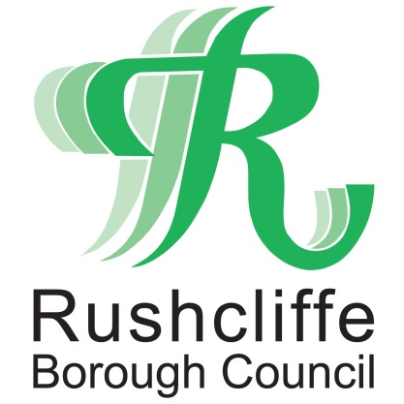 | Press Release

FOR IMMEDIATE RELEASE REF. STREETWISE
04.09.20

Residents thank Streetwise for generous donation to colourful community project

Residents on a street in West Bridgford have thanked Streetwise for donating soil to a colourful community planter that is helping to unite neighbours and bring further life to the street.

The feature, courtesy of ward councillor Liz Plant’s Nottinghamshire County Council divisional funding, has now seen green fingered residents plant the creation that proudly stands at the top of Park Avenue in the town.

The grounds maintenance contractor was pleased to support the project by donating two tonnes of soil that is hoped will bring a further colourful sparkle to the street’s community activities.

Families, neighbours and local councillors met last week to celebrate the donation by replanting an exciting range of flowers and burying their very own time capsule with recent memories from the Avenue.

Streetwise director Nigel Carter joined residents on the Avenue to celebrate the donation and was delighted to witness the whole community getting involved.

He said: “We’re always pleased to be able to help volunteer groups wherever we can to further enhance their projects and local open spaces.

“It’s particularly rewarding to see a planter like this where people have held on to the community spirit of lockdown to help create a brighter, more creative and welcoming space for their neighbourhood.”

Cllr Plant added: “I’m delighted that divisional funding has secured such an important feature for Park Avenue that is now providing enjoyment and meaningful community connections for everyone living there.

“Voluntary efforts like these are fantastic at enhancing our local streets and neighbourhoods and I’m so pleased that we’ve been able to help residents take ownership of their communal spaces.”

Resident Kayliegh Fisher has been helping coordinate efforts to generate good feeling in the neighbourhood during lockdown and was thrilled to discover many of the local children wanted to help look after the planter too.

She said: “This year has been trying for everyone in so many different ways, so it’s absolutely fantastic that this planter has brought our little neighbourhood together as a stronger community during this time.

“We definitely grew closer as neighbours during lockdown, so it’s fantastic to see a project like this harness that energy, bring so much enjoyment to everyone and provide local children, families and neighbours with a practical way to engage with our community.”

- ENDS -

NOTE TO EDITORS
For information please contact the Rushcliffe press office on 0115 9148 555 or media@rushcliffe.gov.uk

For the latest news and events, follow @rushcliffe on Twitter or Rushcliffe on Facebook or go to the council's website.

