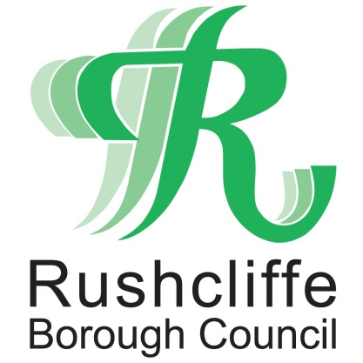 | Press Release

FOR IMMEDIATE RELEASE REF CONSULT
02.09.20
Rushcliffe Borough Council dismiss reports on consultation to end its role in local government

Rushcliffe Borough Council has dismissed media reports it is set to consult its residents on ending its role providing high quality services in light of possible local government reorganisation.

The authority’s Cabinet is reassuring all residents and stakeholders in the Borough a report to its Cabinet, set to be discussed at a meeting on September 8, will explore its role in helping to shape its future, not conclude it in its current format.

Leader of the Council Cllr Simon Robinson said: “Reports the Council is to consult with residents to end Rushcliffe’s current role in local government are wide of the mark.

“On the contrary we want to be at the forefront of debating and working with fellow authorities on the shape it may take in Rushcliffe for the continued benefit of our residents.

“It’s important as a proactive high performing district council, we positively play any part in the format of the future and the Council is committed to keeping residents informed.

“Therefore the report to Cabinet will consider how in the months ahead we may look to positively engage in the wider process and work collectively to identify and consult with partner councils on the best options going forward.”

- ENDS -

NOTE TO EDITORS

For information please contact the Rushcliffe press office on 0115 9148 555 or media@rushcliffe.gov.uk

For the latest news and events, follow @rushcliffe on Twitter or Rushcliffe on Facebook or go to the council's website.

