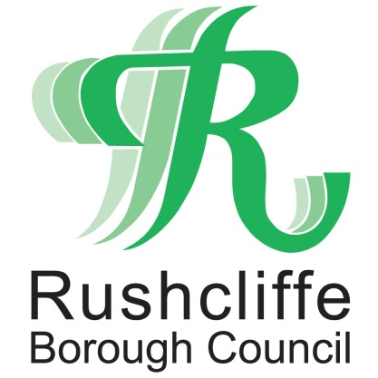 | Press Release

FOR IMMEDIATE RELEASE REF BOARD
01.10.21

Full Council meeting recommends Improvement Board for Bingham Town Council

A Rushcliffe Borough Council (RBC) Full Council meeting has approved recommendations that include working collaboratively with Bingham Town Council and an offer to create an Improvement Board to review its governance.

Earlier this year RBC received a petition from 635 local signatories in the town calling for changes to the Town Council and it has now outlined where it could assist the authority going forward.

Following a report discussed at the meeting last night (September 30) it outlined a unanimous recommendation on the creation of the Board that will offer to review governance and improvement issues.

The recommendation that was passed also asks RBC’s Monitoring Officer to make any necessary changes to the constitution to allow the authority to establish such a group.

Leader of Rushcliffe Borough Council Cllr Simon Robinson said: “We now wish to work with Bingham Town Council and offer assistance with the Improvement Board that can see it make strides forward.

“This is not a talking shop, we want to take action, we want a more efficient and fit for purpose Council.

“We want Bingham Town Council to be a better place to work and its ability to deliver. Bingham is a wonderful unique place that deserves better.

“We’re aware of the points the petition raised and wish to assure Bingham residents who signed it we want to do what we can to steer governance in the right direction if the Town Council accept the assistance.

“Once we engage with the Town Council on this offer of support, we will ensure details of the Board’s proposals will be communicated to all.”

In line with the report, a recommendation was also passed to provide a written response to the petition organisers, indicating its reasons for rejection of the petition and writing to Bingham Town Council and Nottinghamshire County Council to share the contents of the report and what the Full Council meeting resolved.

ENDS

NOTE TO EDITORS

For information please contact the Rushcliffe press office on 0115 9148 555 or media@rushcliffe.gov.uk

For the latest news and events, follow @rushcliffe on Twitter or Rushcliffe on Facebook or go to the council's website.

