Essential Maintenance:

A52 between Barrowby and Saxondale

Traffic Management Bulletin

We are carrying out essential maintenance work on the A52 from 26th February 2018 to late March 2018 we will start to resurface the carriageways.

This work is part of a package of essential maintenance work on the A1, A52 and A46. For further information, please visit: http://roads.highways.gov.uk/programmes/a1-a52-a46-trunk-roads-programme/

Date | Closure | Times
8pm Friday 23rd February until  6am Monday 26th February | A1 / A52 Barrowby Junction  A52 closed between A1 NB entry slip road and Barrowby Gate roundabout  A1 SB entry and exit slip road closed  Diversion route on the reverse | Closed  24 Hours a Day  (Fri 20:00 to Mon 06:00)
Monday 26th February to  Saturday 3rd March | A52 Westbound & Eastbound closed between Barrowby & Sedgebrook  Access will be maintained to properties that can only be accessed from the A52  Diversion route on the reverse | Overnight from  8pm to 6am
Monday 5th March to  Thursday 8th March | A52 Westbound & Eastbound closed between Barrowby & Sedgebrook  Access will be maintained to properties that can only be accessed from the A52  Diversion route on the reverse | Overnight from  8pm to 6am
Friday 9th March and Saturday 10th March | A52 Westbound & Eastbound closed between Barrowby & Sedgebrook  A1 NB slip road closed  Access will be maintained to properties that can only be accessed from the A52  Diversion route on the reverse | Overnight from  8pm to 8am
Monday 12th March and Saturday 17th March | A52 Westbound & Eastbound closed between Barrowby & Sedgebrook  Access will be maintained to properties that can only be accessed from the A52  Diversion route on the reverse | Overnight from  8pm to 6am

NOTE: Please note that all our planned road works are subject to change due to weather conditions or unforeseen circumstances.

We apologise for any disruption; please plan ahead and allow extra time for your journey.
For further information, please contact:

Harold Shaw, Day time Public Liaison Officer
Email: harold.shaw@tarmac.com
Mobile: 07484 029694

Mark Atherton, Night time Site Supervisor
Email: mark.atherton2@tarmac.com
Mobile: 07931 447892

A52 Barrowby to Saxondale, Westbound & Eastbound Diversion Route

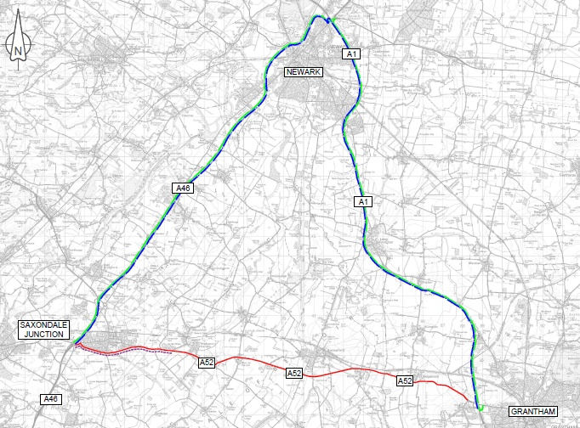

Key:
A52 WB & EB Carriageway/Slip Road Closure

A52 EB Traffic to be advised to Follow Strategic
diversion at Saxondale Junction.

A52 WB Traffic to be advised to Follow Strategic
diversion at A52/A1 SB Slip Road.

40mph Speed Restriction

A1 / A52 Barrowby Junction, Westbound & Eastbound Diversion Route
23rd February to 26th February A52 Westbound & Eastbound & A1 Southbound Exit & Entry Slip Road Closed

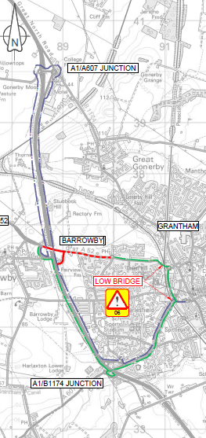

Key:
A52 WB & EB Carriageway/Slip Road Closure.

A52 WB Traffic to be advised to Follow diversion at Barrowby Gate Roundabout.

A52 EB Traffic to be advised to Follow diversion at A1 NB Entry Slip Road.

A1 / A52 Barrowby Junction, Westbound & Eastbound Diversion Route
9th March and 10th March A52 Westbound & Eastbound closed between Barrowby & Sedgebrook, A1 Norththbound Exit & Entry Slip Road Closed

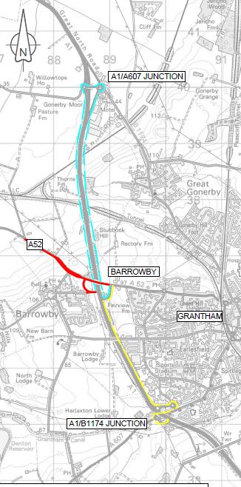
Key:
A52 WB & EB CARRAIGEWAY/SLIP ROAD CLOSURE.

A52 TRAFFIC GOING A1 NB TO BE ADVISED TO FOLLOW STRATEGIC DIVERSION AT
A52/A1 SB SLIP ROAD.

A1 NB TRAFFIC GOING A52 TO BE ADVISED TO FOLLOW STRATEGIC DIVERSION AT
A1/B1174 JUNCTION.

